Annual Report
2023

About QCOSS
Queensland Council of Social Service (QCOSS) is Queensland’s peak body
for the community services sector. We work to improve the lives of Queenslanders by ensuring our sector is strong, connected, engaged, mobilised and heard.
Our work is underpinned by our values of strength, optimism and respect.
We are committed to self-determination for First Nations Peoples.
Our work is evidence based, focused on the whole of Queensland and reflects the views and perspectives of our members. Our members share our vision of equality, opportunity and wellbeing for all Queenslanders and are deeply involved in our work.
QCOSS centres human rights in our decision-making and actions, and we work with the community services sector to promote human rights respecting practices.
We bring our members, the community sector, other peak bodies, government, business and the community together.
Excellent relationships and partnerships are at the core of everything we do.

Contents

Chair’s Report 1
CEO Report 2
Our Strategic Plan 3
Our Year in Numbers 4
Rebooting the system 5
Local communities are empowered 11
Being in Service 13
Leading together 17
Self-determination of First Nations people 21
Walking the talk 23
Meet our Directors 25
Funders and Supporters 28
Financials 30

Chair’s Report | QCOSS Board Chair, Matt Gardiner
1

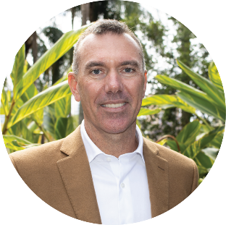
In 2019, the year of our 60th anniversary, I became the QCOSS Chair. That year, our 2019-2023 strategic plan was launched.

I wrote then that underlying our new strategic direction was a “narrative of hope”. The following year, the world was plunged into the COVID-19 pandemic, and that statement took on an unanticipated urgency.
While we are now out of the pandemic lockdowns, the 2022-23 financial year was marked by rising inflation, rate increases, spiralling private rents and sharply declining housing availability and affordability. Once again, our members were inundated with people seeking help. Many people had not needed assistance from our sector before.

As always, the sector responded to increased need with creativity and collaboration. In its resilience, ingenuity and ability to meet and move through the moment, it both offered hope to the people it served and showed how a sector can embody the principles of hope.

Through research, advocacy, and communications, QCOSS’ role in the narrative was to provide a vision of Queensland where equality, opportunity and wellbeing for everyone really is a reality. The strength and reach of the Town of Nowhere campaign was just one example of this. The campaign has thus far resulted in billions of dollars of funding for social housing in Queensland, a housing roundtable and summit chaired by Premier Annastacia Palaszczuk, a limit to the number of rent increases allowed each year and a landmark report that found 300,000 Queenslanders had unmet housing needs.

QCOSS’ 2023-2028 five-year strategic plan will be launched in the second half of 2023. This plan outlines practical ways to harness the immense strength of our sector and realise the vision of equality, opportunity and wellbeing for all Queenslanders. It is underpinned by a theory of change that states: When the community services sector is strong, connected, engaged and mobilised, significant positive change will occur. My hope and belief is that this plan will be powerfully realised over the next five years.
I would like to thank my board colleagues, who contribute their expertise, wisdom and experience to guiding QCOSS’ work in 2022-23.
I would also like to acknowledge the ongoing support of the Queensland Government, the Department of Communities, Housing and Digital Economy, and our many other partners and sponsors.
Finally, I thank the QCOSS members, a deeply engaged and committed group of organisations and people, who continue to inform and improve our work each year.

CEO Report | QCOSS CEO, Aimee McVeigh
2

Every year, we travel around Queensland to meet with our amazing members and talk about the incredible work that they’re doing and the contribution they’re making to our communities.
In 2022-23, we heard about how our member organisations were supporting Queenslanders affected by the statewide housing shortage and cost-of-living crisis. We heard how frontline staff were working with clients impacted by Queensland’s floods, despite also having to deal with their own flooded residences. We learnt that many Queenslanders were accessing social service supports for the first time.
In a year that the tenacity and resilience of the sector was so evident, it’s been humbling to collaborate with and advocate for the organisations who are there for Queenslanders when things get tough.
In that vein, 2022-23 was a year where QCOSS celebrated the work, and workers, of our sector. In September 2022, we hosted our biannual QCOSS conference. Themed Power and Politics of the Care Economy, it spotlighted the vital care work of the social service sector. 2022 was also the inaugural year of QCOSS’ Queensland Community Impact Awards. These awards recognised the extraordinary and often unacknowledged contributions our sector makes to the community.
Our advocacy focused on the needs of the community, and our sector that serves it. We worked with member organisations and the Queensland Government to ensure indexation levels better reflected the increasing costs of service delivery – resulting in a $50 million funding boost for our sector. Alongside Change the Record, we campaigned to raise the age of criminal responsibility in Queensland from 10 to 14-years-of-age, starting with seeking funding for an alternative to the justice system.
In the second year since its relaunch,
Town of Nowhere campaign advocacy resulted in rental reform and more funding for social housing. The campaign commissioned report: A blueprint to tackle Queensland’s housing crisis by UNSW Professor Hal Pawson, had a huge impact on the efficacy of our advocacy. The day the report was released, the premier announced that her government would explore rental caps. With 300,000 Queenslanders currently experiencing housing need, we continue to work with our campaign partners to end the housing crisis.
As our Living Affordability Report demonstrated this year, it is almost impossible for low income families to get by. Together with the Power Together campaign we called for initiatives that would bring down power prices as we transition to renewables. Our advocacy resulted in bill relief that is worth up to $1000 per bill per year, support to assist people on low incomes to pay for appliances to make their home more energy efficient and funding for community organisations to support people on low incomes to reduce their power bills.
As a feminised workforce, we have a particular focus on women’s equality and economic security. Working with our Women’s Equality Network, QCOSS has been seeking to have gender responsive budgeting implemented in Queensland. After successfully advocating for this commitment to be included in the Queensland Women’s Strategy, this year saw the Queensland Government apply this practice to their budget process for the first time.
In the next 12 months, we will draw on the power of our sector as we continue to advocate for equality, opportunity and wellbeing for all Queenslanders. We will campaign for housing to be treated as a universal right and for children to be kept out of prisons. We will advocate for better funding arrangements for the social service sector and cost of living relief.
Thank you to the QCOSS team for the passion, skill, expertise and dedication they bring to their work - their number is far outweighed by their achievements as is evidenced in this report. Thank you to the people with lived experience of the issues on which we advocate who shared their stories and called for change.
As always, thank you to our member organisations and partners; when our sector collaborates, we are powerful. The incredible work you do is a source of inspiration and hope for a fairer, more equal Queensland.

Our Strategic Plan | 2021 – 2023
3
In response to the disruption caused by COVID-19, considering the potential for positive change associated with Queensland’s Human Rights Act and in order to highlight our commitment to self-determination for First Nations People, we re-set our strategic plan in 2021.

The strategic direction and intent of the organisation has not changed. Rather, the plan has been refined and developed, including to ensure our impact is measurable.

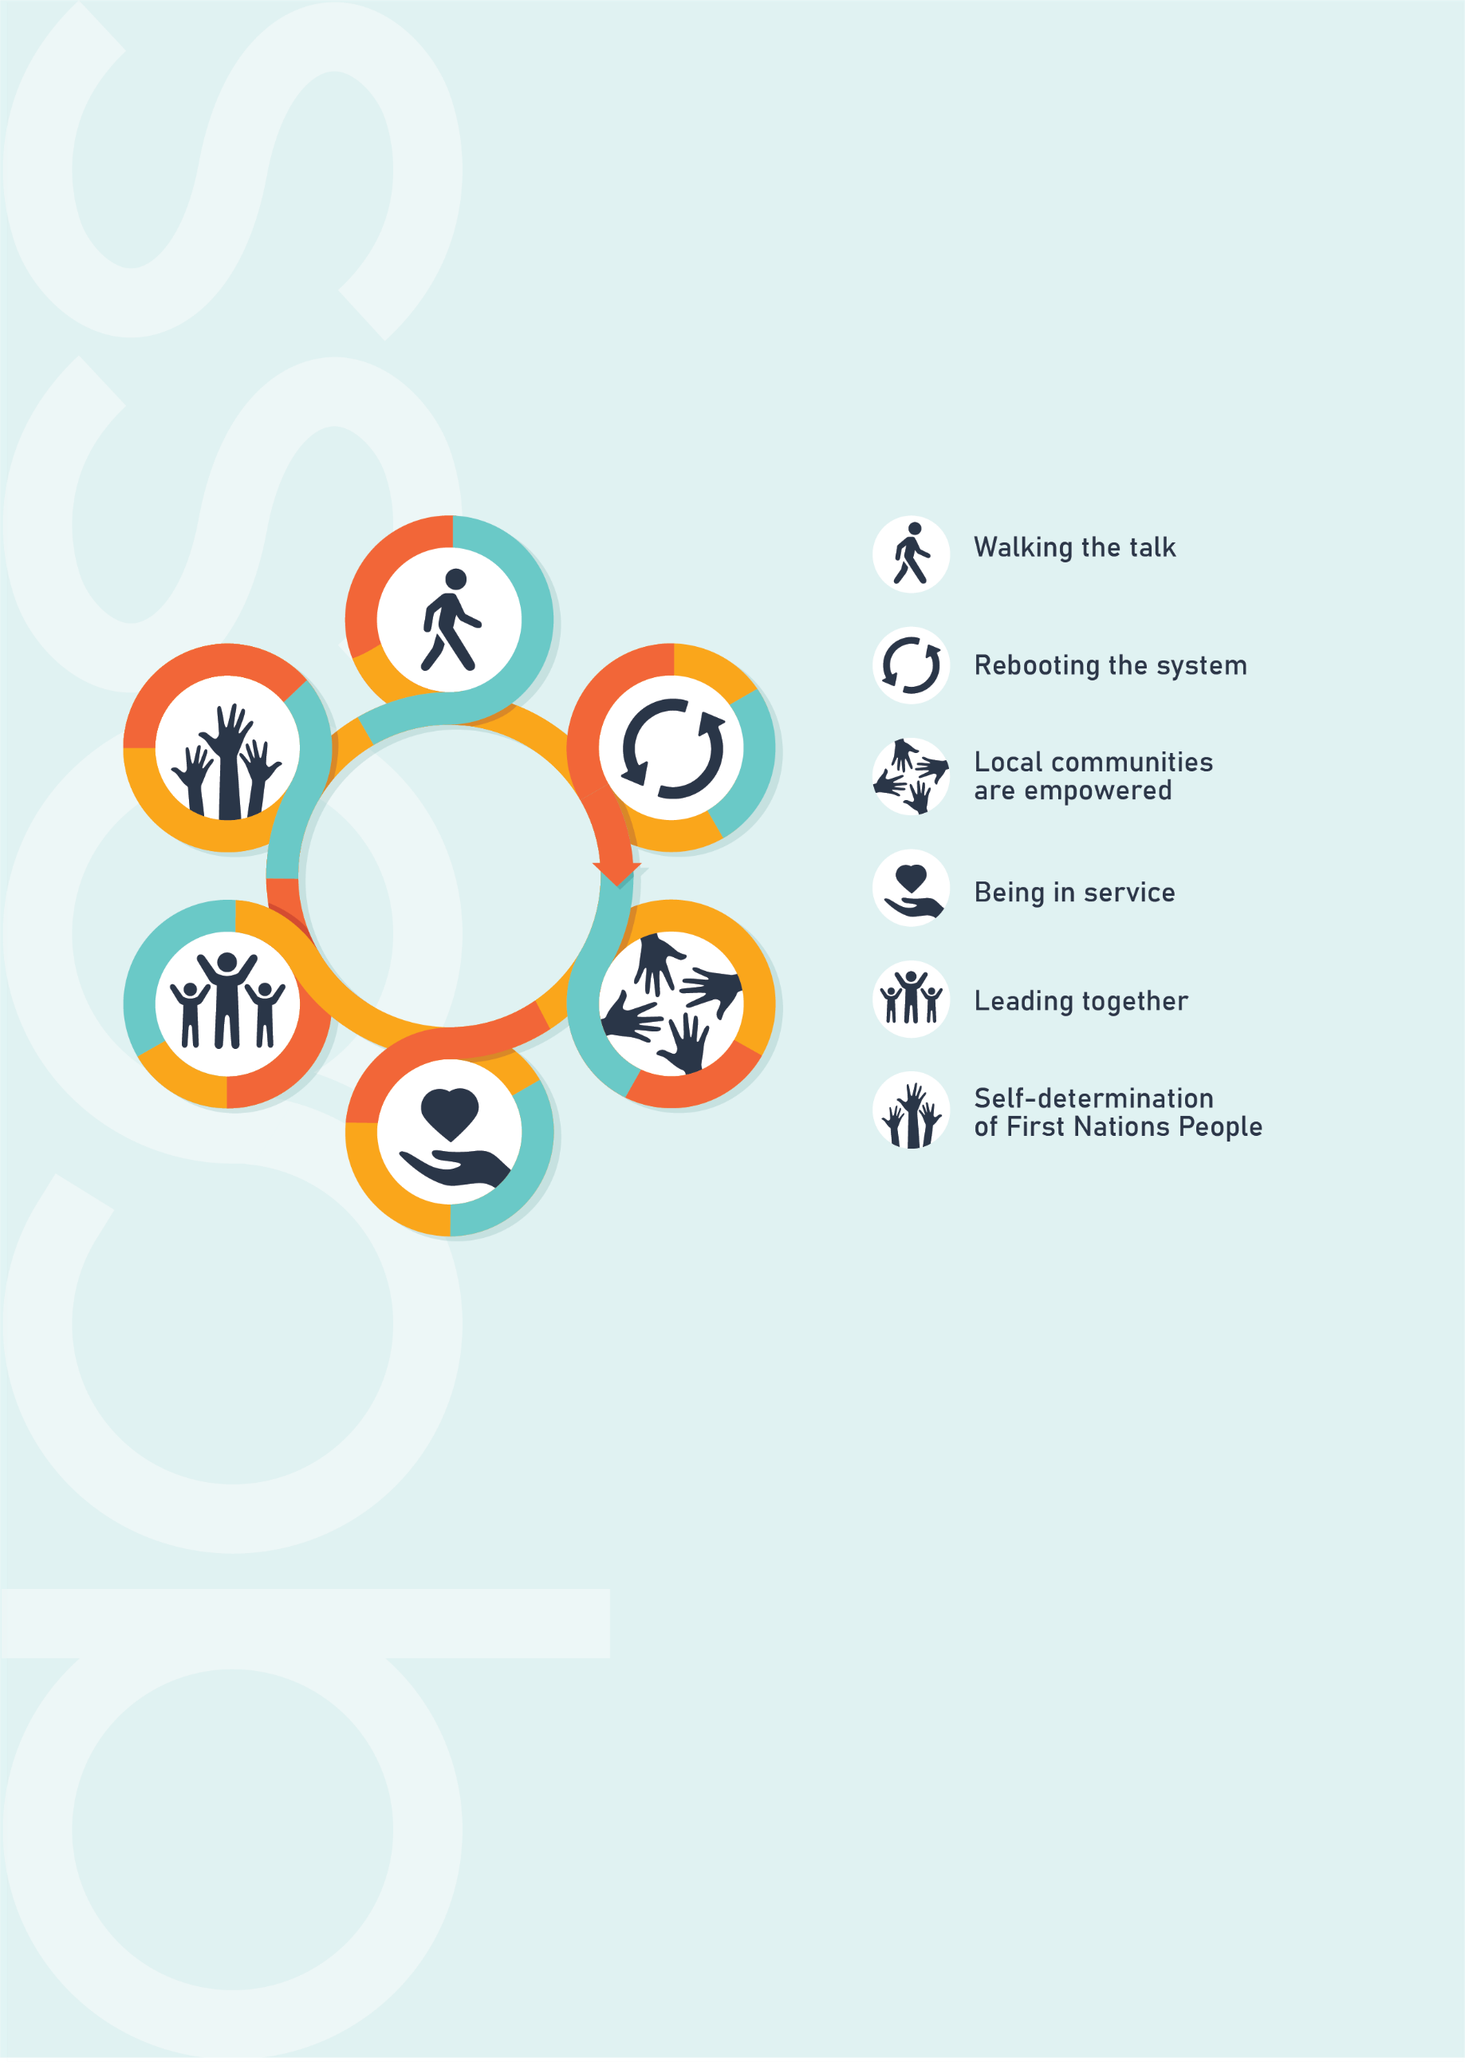

Our new five-year Strategic Plan begins in the second half of 2023. Developed in consultation with the Board, the Executive Directorship team and QCOSS staff, the plan aims to build and harness the power of a strong, connected, engaged and mobilised social service sector to engender significant positive change in Queensland.

Our Year in Numbers
4
62,512 individuals
accessed the QCOSS website.
191,745 people viewed Community Door.
363 people attended the
QCOSS Conference
57.28 million people
were reached
by
3,460 QCOSS
media appearances
We have
461 members.
We made
12 policy submissions.
We supported
24 letters/
submissions
led by other organisations.
31,074 copies
of Conduit were
sent out.
98 events were held.
3,463 people
registered
for our events.

Rebooting the system
5
Overturning systems and structures that create and perpetuate inequality
QCOSS advocated to get a roof over the head of every Queenslander,
keep children under 14 out of prison, reduce the cost of living,
gain gender equality and reduce poverty.

- Ensure public funds are used to improve
the lives of people experiencing disadvantage
Over the past twelve months, the cost of living in Queensland has grown higher and higher,
putting incredible pressure on Queenslanders, particularly those on low incomes.

Increasingly, services are handing out swags and tents, or paying for car registrations and repairs for Queenslanders unable to secure housing. Working families are requesting emergency relief, including food packages, and taking additional jobs to be able to afford the basics.

With Brisbane preparing to host the Olympic Games in 2032, the coming decade presents an invaluable opportunity to ensure all Queenslanders have a baseline living standard that includes permanent stable housing. To this end, in 2022-23, QCOSS called on the Queensland Government to invest in strategic, long-term initiatives that reduce homelessness and inequality.

QCOSS’ 2022-23 Budget submission contained the following asks:
- A viable and human rights respecting community services sector
- Invest in Queensland’s youth services sector
- End Queensland’s housing crisis
- Advance women’s equality
- Help low-income households access energy transformation
- Reduce digital disadvantage
- Give all children a good start

On 15 June 2023, the Queensland Government’s budget announcement included:
- A rise in indexation to 5.6 per cent for the community service sector.
- Increased funding of $29.4 million over four years for place-based diversionary responses for young people, including after-hours support, cultural mentoring, bridging to flexi-school and case management, and alternative opportunities and activities for at-risk young people.
- An increase of $802.8 million over five years to deliver housing commencement targets under the Housing and Homelessness Action Plan across Queensland.
- A record $8.224 billion in total concessions funding in 2023–24, an increase of 21 per cent from 2022–23. This includes $1.617 billion in new and expanded cost of living relief.
- $1.483 billion of additional electricity bill support to households and small businesses facing cost of living pressures.
- $645 million over four years to provide 15 hours per week of free kindergarten from January 2024 for all four-year-old Queensland children.

6
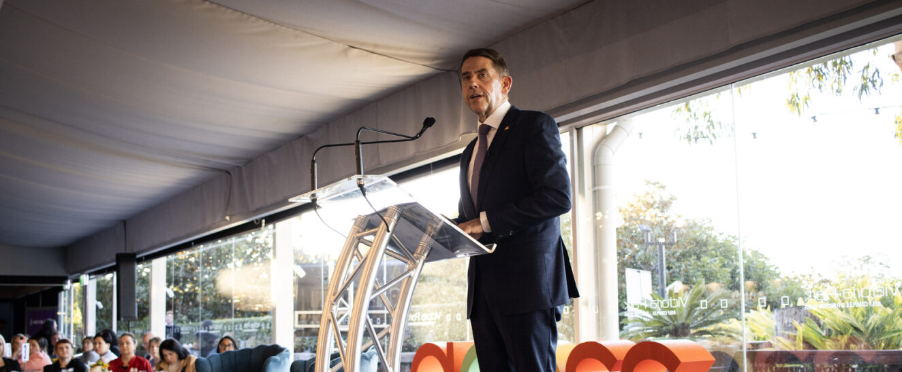
Budget Breakfast: The annual QCOSS Budget Breakfast was held on 20 June 2023. It was attended by 364 people including QCOSS members, Queensland peak bodies and government department representatives. Treasurer and Minister for Trade and Investment, the Hon Cameron Dick MP presented Queensland’s 2023 Budget and spoke about its impact on the social services sector.

We were pleased to welcome a number of government ministers, including:

- Hon Cameron Dick MP, Treasurer and Minister for Trade and Investment
- Hon Leeanne Enoch MP, Minister for Treaty, Minister for Aboriginal and Torres Strait Islander Partnerships, Minister for Communities and Minister for the Arts
- Hon Di Farmer MP, Minister for Employment and Small Business, Minister for Training and Skills Development and Minister for Youth Justice
- Hon Mark Furner MP, Minister for Agricultural Industry Development and Fisheries and Minister for Rural Communities
- Hon Meaghan Scanlon MP, Minister for Housing
- Charis Mullen MP, Assistant Minister for Treasury

7

- Respond to Queensland’s housing crisis
Housing is the cornerstone of a person’s wellbeing.
QCOSS’ Town of Nowhere campaign has the objective of putting a roof over the head of every Queenslander by 2032. Housing is the cornerstone of a person’s wellbeing. We believe housing policy and planning must be based on the principle that access to appropriate and secure housing should be a universal right in Australia, like healthcare.
In 2022-23, the campaign continued to call for more funding, accelerated construction of social housing, improved rights for renters and increased income support. It also presented the Queensland Government with an ambitious ten-year vision that aims to develop a whole of government housing plan, leverages Commonwealth Government commitments and focuses on delivering supply of social and affordable housing, making the private rental market fair and ensuring the implementation of the plan is well managed and transparent.
To establish an evidence base, the Town of Nowhere campaign partners, alongside Tenants Queensland and The Services Union, commissioned the groundbreaking report: A Blueprint to Tackle Queensland’s Housing Crisis. Written by Hal Pawson, Professor Housing Research and Policy and Associate Director at UNSW’s City Futures Research Centre, the report found that 300,000 Queenslanders had unmet housing needs. It successfully changed the conversation about housing in Queensland.
This advocacy resulted in a Housing Summit (20 October 2022), and two Housing Roundtables (16 September 2022 and 28 March 2023) chaired by Queensland Premier Annastacia Palaszczuk where the Queensland Government committed to:

- build 2,300 new social and affordable homes each year for five years
(up from 500)
- limit to the number of rent increases allowed each year
- halve land tax for Build-to-Rent developments
- deliver a $28 million boost for
emergency housing.

8

Make Renting Fair in Queensland: QCOSS is a member of the Make Renting Fair Alliance, an alliance of community organisations who support progressive reform of state renting laws so that all Queenslanders can make the place they live in their home, whether they rent or own.
- Raise the age of criminal responsibility in Queensland
In 2022, QCOSS partnered with First Nations-led coalition, Change the Record, to coordinate the Queensland Raise the Age campaign. This campaign aims to raise the age of criminal responsibility in Queensland from 10 to 14-years-of-age and asks the Queensland Government to commit to funding trauma-informed, therapeutic, culturally safe, non-punitive programs that keep children out of the legal system.

In 2022-23 we employed a Raise the Age Campaign coordinator, established the Queensland Raise the Age Leadership Group made up of 40 organisations and facilitated Raise the Age media training in Townsville, Cairns and the Gold Coast. We also established local service groups in Townsville, Cairns, Gold Coast and Toowoomba with community programs which are empowering children involved in the justice system.

- Reduce poverty and inequity in Queensland
QCOSS advocacy campaigns aimed at reducing poverty and inequity in Queensland

- Power Together: QCOSS is a member of Power Together, an alliance of advocacy organisations who want to re-imagine and unlock the powers of renewable energy to reduce cost of living pressures for all Queenslanders.
- Raise the Rate for Good: QCOSS is part of Raise the Rate for Good, a community of more than 20,000 people campaigning to raise the rate of federal income support and ensure everyone has enough to cover the basics.
Of the six households modelled in the report, five were unable to afford a basic standard of living.
Living Affordability in Queensland report: QCOSS’ 2022 Living Affordability in Queensland report found that low-income Queensland households are feeling the effects of high inflation, rising energy costs and low housing affordability. Of the six households modelled in the report, five were unable to afford a basic standard of living and all spent more than 30 per cent of their income on housing.

Unpacking Automation in Social Services: In support of Anti-Poverty Week 2022, QCOSS partnered with the University of Queensland’s ARC Centre of Excellence for Automated Decision Making and Society to deliver: Unpacking Automation in Social Services, a roundtable with American political scientist and award-winning author, Professor Virginia Eubanks.

9
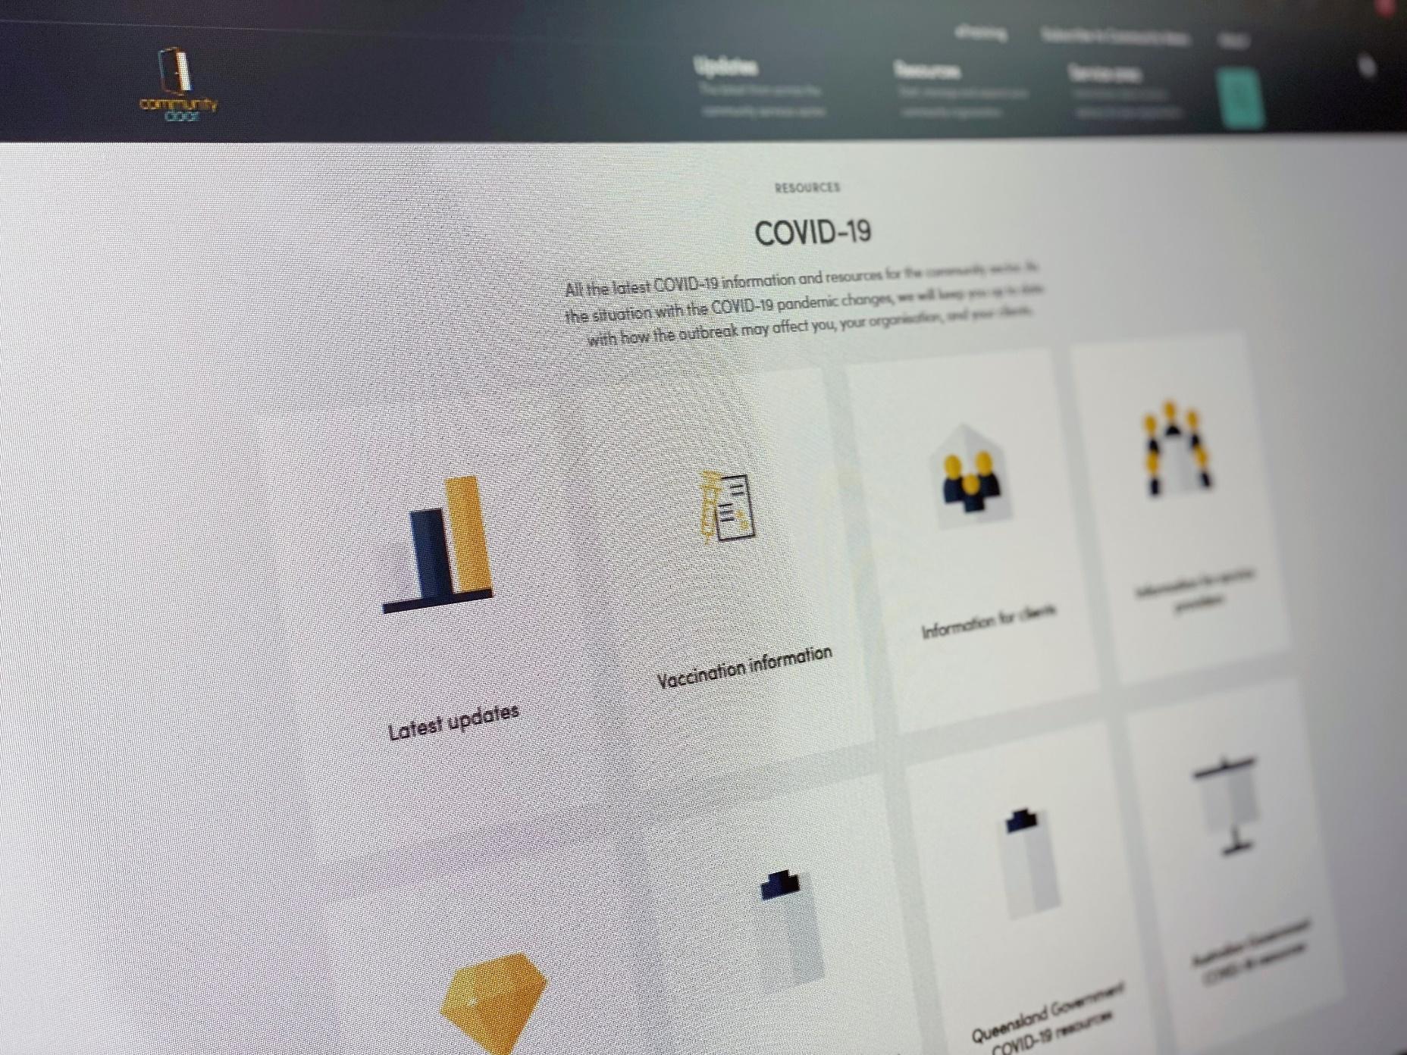

- Participate in disaster response and recovery so that the needs
of the most disadvantaged people in Queensland and the services that support them are given priority attention.
The Community Door COVID-19 hub was visited more than 37,200 times during 2022-23.
COVID-19 Hub: Until the end of 2022, QCOSS delivered regular updates to the community services sector about COVID-19 using our full range of communications channels. The Community Door COVID-19 hub was visited more than 37,200 times during 2022-23, with more than 15,000 users accessing our Latest Updates page to keep on top of restrictions.

- Improve gender equality in Queensland
Gender responsive budgeting: In 2021-22, QCOSS called on the Queensland Government to enhance approaches to gender responsive budgeting (GRB) and ensure gender impacts are considered in government policy and decision-making. In line with commitments under the Queensland Women’s Strategy 2022-27 (QWS), the Queensland Government has expanded its engagement with GRB. Bids in the 2023/2024 budget were assessed against the impact areas of the QWS. Notably, this process resulted in additional measures aimed to address women’s economic security.

100

QCOSS policy input and advocacy 2022-23
Among other tactics, QCOSS uses submissions and participation in government managed committees and processes to provide policy input and advocate for better outcomes for Queenslanders.
Submissions included:

- Independent Commission of Inquiry into Queensland Policy Service responses to domestic and family violence (2022)
- Government consultation discussion paper on the approach to delegated authority implementation (2023)
- Parliamentary Committee Inquiry into the decriminalisation of certain public offences, and health and social welfare responses (2022)
- Stronger Laws for Community Safety review (2023)
- Strengthening Community Safety Bill (2023)
- Family and Child Commission Act 2014 review (2023)
- Path to Treaty Bill 2023 (Qld) (2023)
- Integrity and Other Legislation Amendment Bill (2023)
- Stage 2 Rental Reform Options Paper (2023)
- Youth Justice and Child Wellbeing Reform across Australia (2023)
- Planning (Inclusionary Zoning Strategy) Amendment Bill (2023)
- Inquiry into Australia’s Human Rights Framework (2023)
- Draft National Care and Support Economy Strategy (2023)

We participated in the following government managed committees and processes:

- Brisbane 2032 Olympics and Para-Olympic Games Legacy Forum
- Community Services Industry Board
- Departmental-Peaks Service Delivery Communication and Liaison meeting
- EWOQ Advisory Council
- Housing and Homelessness Services Peaks and Industry Sector Group meeting
- Housing Roundtable and Summit
- Ministerial Energy Council
- Ministerial Resource Recovery Roundtable
- Public Trustee Customer Reference Group
- Queensland Care Consortium
- Responsible Gambling Advisory Committee
- Social Services Category Council Industry Reference Group
- Community Partnerships Group (Queensland Family and Child Commission)
- Departmental Peaks Service Delivery Communication and Liaison
- Housing and Domestic and Family Violence Roundtable
- Human and Social Recovery Committee
- Procurement Industry Advisory Group
- Queensland Legal Assistance Forum

Local communities are empowered
110
Ensure Queenslanders can influence decisions that impact their lives
We worked to make sure the voices of our sector and community
were heard by government and Queensland communities.

- Provide a connection between the community and
the government so that local voices are heard
Gold Coast Homelessness Network: QCOSS is an active partner in the Gold Coast Homelessness Network (GCHN), working to deliver the Service Integration Initiative and to end homelessness on the Gold Coast. As Regional Care Coordinator for the project, QCOSS works closely with the network to enhance engagement between services on the coast – encouraging collaboration and building the sector’s capability to create a more holistic response to homelessness.
In 2022-23, the GCHN delivered the annual Gold Coast Homelessness Symposium. Themed “Connecting Communities”, it was attended by 120 representatives from across the community services sector. In June 2023, following advocacy from the GCHN for greater investment into locally based food aid, The Gold Coast Food Hub was launched. The food hub provides much needed infrastructure for the storage, distribution, and coordination of food aid in the region.

On Country program evaluation: QCOSS evaluated the On Country program for the Department of Children, Youth Justice and Multicultural Affairs (DCYJMA). The On Country program is designed to prevent young people from reoffending. It connects justice-involved First Nations young people with First Nations adults, Elders and Traditional Owner mentors who transfer cultural knowledge to their mentees.
Across Mount Isa, Cairns and Townsville, 38 people were interviewed, while a further 22 First Nation community members participated in a community forum in Mount Isa during December 2022. As a result of the QCOSS evaluation, the program received ongoing funding.

Customer Impacts of Cashless Public Transport: This QCOSS report, commissioned by Translink, investigated how stopping cash transactions for public transport tickets during the COVID-19 pandemic impacted bus, train and ferry users in South East Queensland.
The findings were supported by a QCOSS survey of 35 frontline community service sector workers and 103 community members who either used or had used public transport. QCOSS also conducted four focus groups with clients of community service organisations.

Barriers to accessing electricity rebates: This QCOSS report, commissioned by the Department of Energy and Public Works (DEPW), gathered evidence on the barriers limiting uptake of the Electricity Rebate by Health Care Card (HCC) holders, and provided potential solutions to improve uptake.
QCOSS conducted semi-structured interviews with energy retailers, government stakeholders and community service organisations. The report also drew on results from the Australian Community Sector Survey and a QCOSS consumer cost-of-living survey with over 500 respondents.

120

- Empower people and organisations to tell their stories
Frontline Hero profiles: Workers on the frontline of community services across Queensland are the heart of our sector. In 2022-23, more than 30 sector heroes opened up about their career paths, career challenges, motivations and joys outside of the workplace for our Frontline Hero profiles.
The profiles were shared across our social media channels and in our member newsletter.
Workers on the frontline of community services across Queensland are the heart of our sector.
Town of Nowhere Campaign profiles: We were grateful to those Queenslanders experiencing homelessness who gave us permission to film them telling their stories and build awareness of our state’s housing crisis for our Town of Nowhere campaign profiles. Upendo, Brett and Kristin put human faces on a staggering statistic; currently 300,000 Queenslanders have unmet housing needs.

Raise the Age media training: QCOSS ran Raise the Age media training for community service sector organisations who work with young people in Townsville (March 2023), Cairns (April 2023) and the Gold Coast (May 2023). Together, the three workshops had 26 attendees.

Being in service
130
Support the social services sector
QCOSS successfully advocated for an increase to sector funding
more in line with indexation. We provided sought after skills
and training workshops to community service organisations.

- Improve the business environment and working conditions
for community organisations and workers in Queensland
Increase indexation for the community services sector: QCOSS and partner community organisations commissioned the University of Western Australia to author the report: Queensland’s Cost Indexation for Government Purchasing of Human Services. It was released in March 2023. The report highlights that the current approach to calculating indexation is not adequate for community services. A briefing paper accompanying the report proposed an indexation rate rise.

On 15 June, at the QCOSS Queensland Budget Breakfast, Queensland Treasurer and Minister for Trade Investment, the Honourable Cameron Dick, announced the indexation support rate for non-government organisations was rising from 3.88 per cent to 5.63 per cent. This represented a funding injection of $50 million for Queensland’s community organisations.
The indexation support rate for non-government organisations was rose from 3.88 per cent to 5.63 per cent.

Social Services Category Council (SSCC): QCOSS participated in the Social Services Category Council (SSCC), which governs the category strategy for the social services spend profile across the Queensland Government.

- Supporting the attraction and retention of a skilled workforce
Growing Workforce Participation: Funded by the Queensland Government’s Growing Workforce Participation Fund, QCOSS’ Supporting diverse workforces project was a sector strengthening program of work designed to develop the human resources capability of Queensland community service organisations.

The project delivered a series of four Community of Practice workshops that stepped participants through the value of genuine diversity and inclusion in the workforce, the development of a human resources strategy, how to implement and maintain a strategy, and what inclusive recruitment practices look like. It had 226 registrants. The project was championed by Paralympian and social worker, Karni Liddell, diverse and inclusive workplaces expert, Christine Mudavanhu, and Indigenous Workstars recruitment specialist, Lachlan Anderson.

Queensland Care Consortium: QCOSS was invited to join the Queensland Care Consortium (QCC),
a partnership between Jobs Queensland and peak bodies from the Health and Community Services sectors that aims to support industry-led, government enabled activities that improve workforce development, attraction and retention. In 2022-23, the QCC supported a competitive funding round
that saw seven successful applications funded to a total value of more than $1 million.
140

- Strengthening the operation of community services
Human Services Quality Framework (HSQF): The HSQF assesses and promotes improvement in the quality of human services for the Queensland Government. To help organisations implement quality systems and prepare for their quality assessment activities, QCOSS provides one-on-one and small group support, as well as information and resources, including an HSQF eTraining course and policy templates. In 2022-23 the Quality page on Community Door was updated with a suite of new video resources; the page had 1,039 views. More than 20 organisations received one-on-one HSQF support, and QCOSS hosted regional HSQF workshops as well as providing HSQF auditor training.

Quality Collaboration Network (QCN): The QCN meets monthly to support enhancing collaborative practice in the human services sector by identifying and discussing common issues and compliance matters, as well as sharing information, resources and learning. In 2022-23 QCN meetings had more than 700 registrants overall. They focused on topics ranging from cybersecurity to how to talk to your board about quality and compliance. A QCN Microsoft Teams channel was also launched to support peer-to-peer engagement and collaboration. It grew to 117 engaged users. The 2022 annual QCN evaluation survey reported that 100% of QCN participants would recommend the network to a colleague.

Community Door: The Community Door website provides news, resources and information for Queensland’s community sector, including a fortnightly newsletter. More than 470 news items featuring updates, events and resources were published on the site during 2022-23. The website was viewed 191,745 times by 105,455 users.

Governance and leadership: In 2022-23, QCOSS developed and launched a new online library dedicated to governance. Resources included templates, guides and a video series featuring community services and First Nations organisations around Queensland. The page was accessed 4,201 times by 2,662 users. QCOSS also partnered with Australian Indigenous Governance Institute and Whitsundays Stronger Communities to deliver tailored governance workshops.

Skilling Queenslanders for Work (SQW): QCOSS, in partnership with the Department of Youth Justice, Employment, Small Business and Training (DESBT), delivered tender writing workshops and webinars to both support the Skilling Queenslanders for Work (SQW) initiative and build sector capacity to apply for funding. During 2022-23, QCOSS delivered 22 webinars and in-person sessions across Queensland to 645 people.

Energy and Water: QCOSS provides policy makers with input into policy decisions and regulations related to essential energy and water services and helps to educate the sector on issues and policy changes. Advocacy work in 2022-23 included calling on the Queensland Government to help low-income households access the energy transformation, energy subsidy awareness and educating renters about their rights around energy and water issues.

In Conversation: QCOSS’ In Conversation event series, delivered in partnership with the QUT Centre for Justice, gives the community service sector exclusive access to big ideas from Queensland’s political leaders and policy makers. In 2022-23 we welcomed:
- Hon. Mick de Brenni MP | Queensland Energy and Jobs Plan
- Queensland Treasury Corporation CEO and former Under Treasurer Leon Allen | Budget edition

150

- Support the transformation to a human rights
respecting, culturally competent sector
QCOSS developed resources to support the sector’s understanding of the submission process and how to write a submission.
In 2022-23, QCOSS developed resources to support the sector’s understanding of the submission process and how to write a submission. These were downloaded 269 times during the year. We formed a partnership with Caxton Legal Centre to deliver a three-part series on decision-making and capacity, and we relaunched our Human Rights in Action newsletter. Newsletters were delivered to more than 2,300 recipients.

160

In 2022-23, 681 people registered to attend our Human Rights in Action events.
These included:

- Decriminalisation of Public Offences
- Discussing delegated authority in the Child Protection Act
- Supported decision making and the Public Trustee of Queensland
- Understanding the Inquiry into Australia’s Human Rights Framework
with the Australian Human Rights Commission
- Accidental Advocates
- The role of a functional entity
- How do you prepare and write a submission?
- Anti-Discrimination Act Review with the Queensland Human Rights Commission

Leading together
170
Harness the power of the social services sector and the community.
We listened to, collaborated with and celebrated
our members and Queensland’s social services organisations.

- Build the capacity of organisations and the sector collectively to use data, including the experience and perspectives of service users, to design and improve services and measure outcomes.

Research and Evaluation Network: This network provides an opportunity for collaboration and knowledge sharing on research and evaluation methods. The network meets regularly to hear from guest speakers about their own organisational data collection and service evaluation systems.
In 2022-23, seven webinars were held with more than 380 people attending. The Microsoft Teams research and engagement group has grown to 76 active users in the reporting period.

Using consumer data for continuous improvement: QCOSS partnered with Queensland Positive People, St Vincent de Paul Society Queensland and Communify Queensland to create the report Using consumer data for continuous improvement. The report identifies how organisations can use consumer data to improve their programs on an ongoing basis.

Data Collaborative Demonstration Project: QCOSS’ Data Collaborative Demonstration Project, in partnership with QUT, highlights the benefits of data sharing for community service organisations with the aim of developing a community led and operated data sharing platform. In 2022-23, QUT completed the collective data analysis. QCOSS and QUT presented these initial findings and analysis of the project to participating organisations.

Data support for individual organisations: QCOSS provided data support to 14 organisations across Queensland. The support helped organisations access and interpret local community data to inform service planning. For example, The Council to Homeless Persons (Qld) used data to support the development of a Professional Framework and Guidelines for the Housing and Homelessness sector.

Providing data profiles for the Queensland community service sector: We provided data profiles for the Queensland social housing register and, in partnership with Infoxchange, we created regional data profiles for specific Queensland towns to share with members and the sector through the Town Halls.

180

- Ensure we know what is happening in the
community services sector and community
Town Halls: QCOSS held Town Halls in Toowoomba, Rockhampton, Cairns, Ipswich, Gympie, Brisbane, Mackay, Gold Coast and Townsville. These were practical, in-person sessions exploring the emerging issues in local communities across Queensland. The Town Halls informed the development of our annual State of the Sector report, provided the basis of our Queensland budget submission, and delivered a vital stream of information for QCOSS to feed back to government. They were also an opportunity to engage regional media with stories related to the housing crisis. More than 400 people from across the sector attended.

State of the Sector report: This annual report outlines issues impacting social service sector users and providers. Information is gathered from Town Halls, the Australian Community Sector Survey and through in-depth interviews. In 2023, the report found that the key issues affecting service users were living affordability, housing, health, unsafe home environments, youth wellbeing, transport, natural disasters and the digital divide. Issues impacting service providers included intensity of demand, funding adequacy, natural disasters and workforce retention. Service providers pointed to collaboration and innovation as central to helping the sector overcome some of the identified challenges.

- Networks and influence
QCOSS policy networks identify shared sector challenges, emerging issues, and advocacy priorities, and collaboratively generate solutions. They are:

- Research and Evaluation Network: members collaborate and share knowledge on data collection and service evaluation systems. The network met seven times in 2022-23 and has 360+ members.

- Community Services CEO Network: members shape solutions to issues impacting the sector with a focus on structural reform. The network met four times during 2022-23 and has 99 members.

- Women’s Equality Network: members respond to and provide advice on matters relating to women’s equality. The network met four times during 2022-23 and has 20 members.

- Essential Services Consultative Group: members influence energy policy processes and contribute to government policy on key consumer reforms. The network met five times during 2022-23 and has 22 members.

- Quality Collaboration Network:
members share experiences, information and resources on audit and quality matters. It provides valuable feedback to government on the HSQF review process. The network met 10 times during 2022-23 and has more than 500 members.

- QCOSS also convened
the Queensland Peaks Network:
members identify sector issues and share perspectives. The Queensland Peaks Network met four times during 2022-23 and has 29 member bodies.

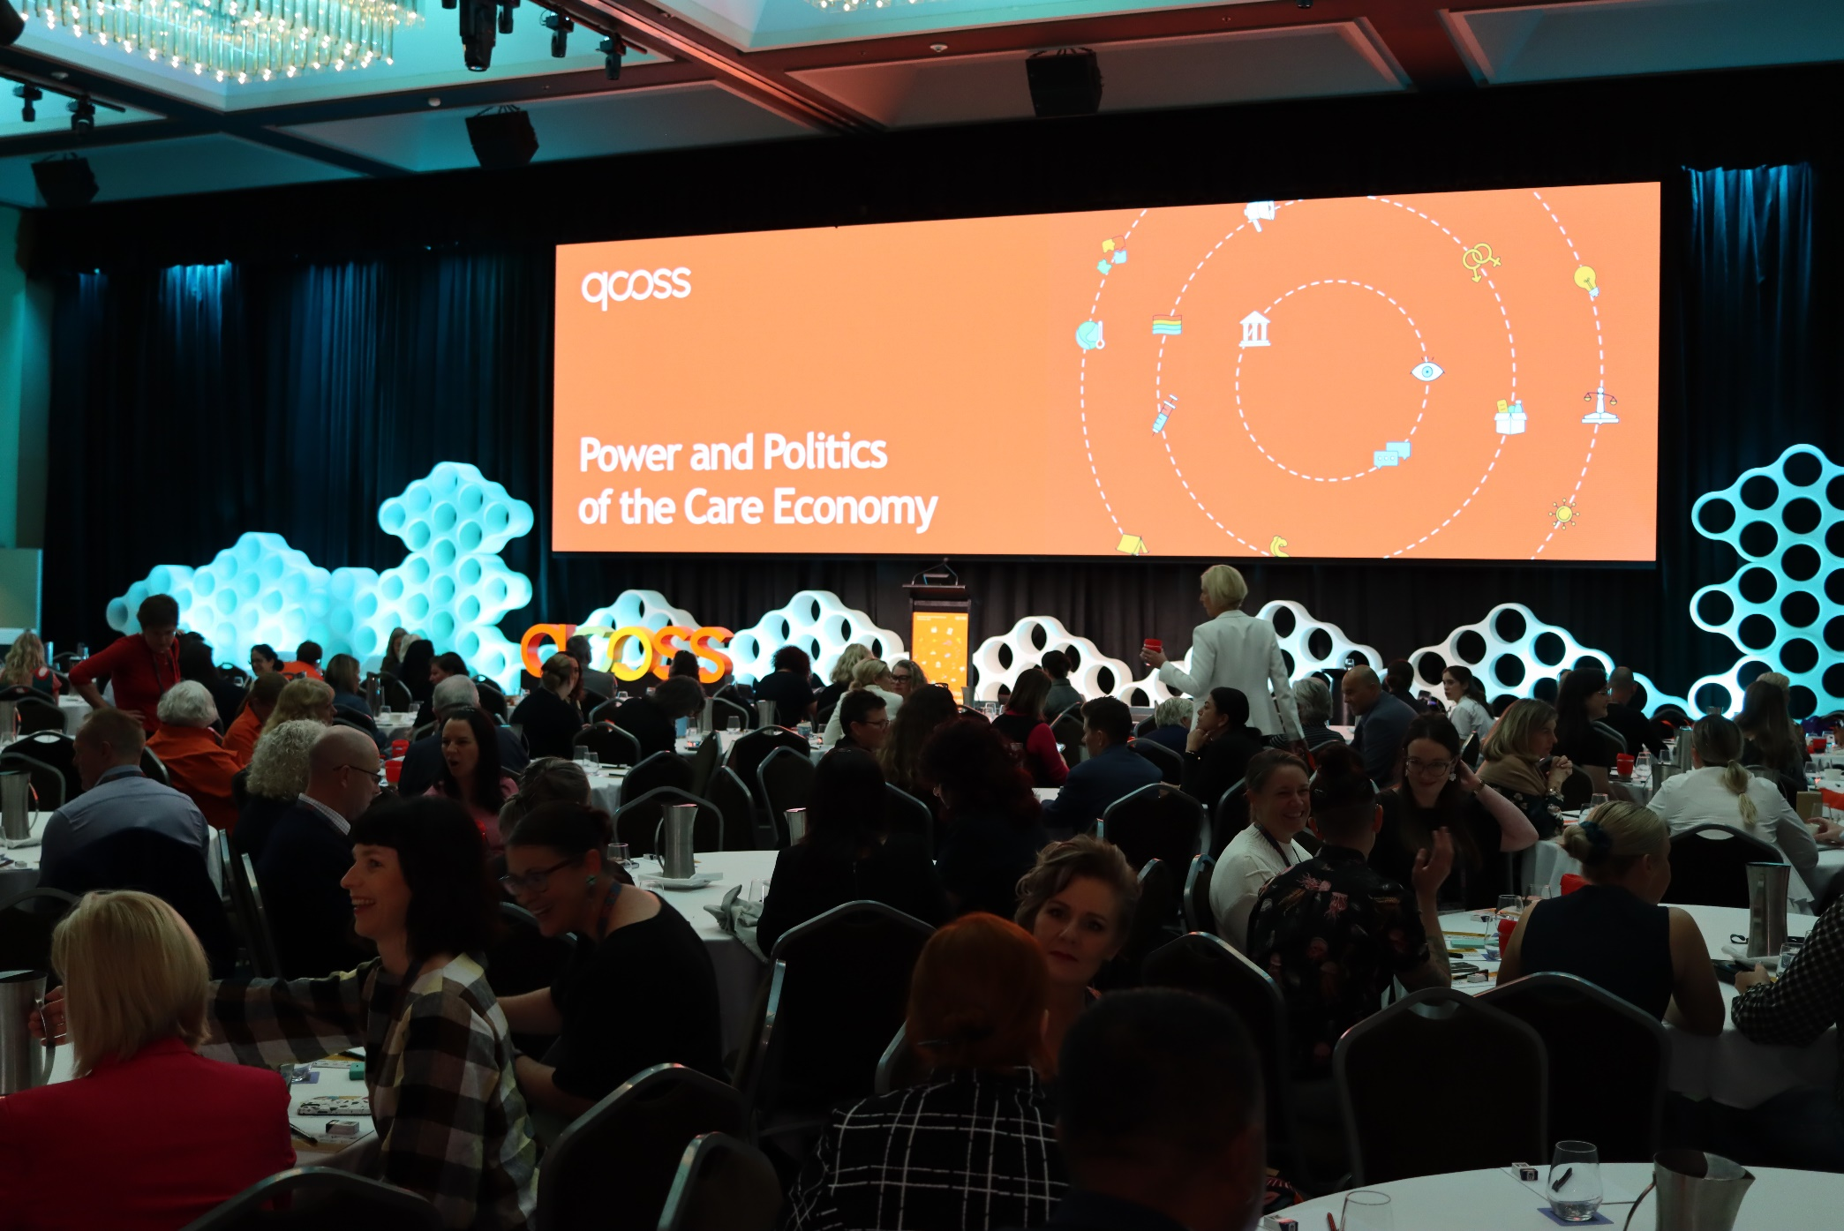
19

- Provide opportunities for the community services
sector to connect and build relationships.
QCOSS Conference: The QCOSS Conference: Power and Politics of the Care Economy ran from 6 to 8 September 2022. The conference was attended by 385 delegates from across Queensland’s social service sector and featured two networking events, an art exhibition and 12 breakout sessions on the following topics:

- Recent trends in not-for-profit governance
- Leading for impact
- Achieving economic security for women
- Our power in action – community-led change
- The future of social housing: innovative solutions from the ground up
- Developing our future workforce
- Raising the age: transforming youth justice
- Data sharing and collaboration to advance outcomes across our sector
- Climate justice: community resilience
- Children’s rights
- Breaking entrenched systems of disadvantage and discrimination
- Connecting the community sector
with the arts to achieve social change

Keynote speakers included Grace Tame, Professor Megan Davis, Hon. Leeanne Enoch MP, Hon. Di Farmer MP, journalist Amy Remeikis, Dr Amy MacMahon MP, Tim Nicholls MP and Queensland Human Rights Commissioner Scott McDougall. The event was emceed by Paralympian and social worker Karni Liddell. Keynote speeches centred on gender, the economics of care work, power, politics, the Uluru Statement from the Heart and discrimination in Queensland.

A post-event satisfaction survey showed that 95% of attendees were either very satisfied or satisfied.

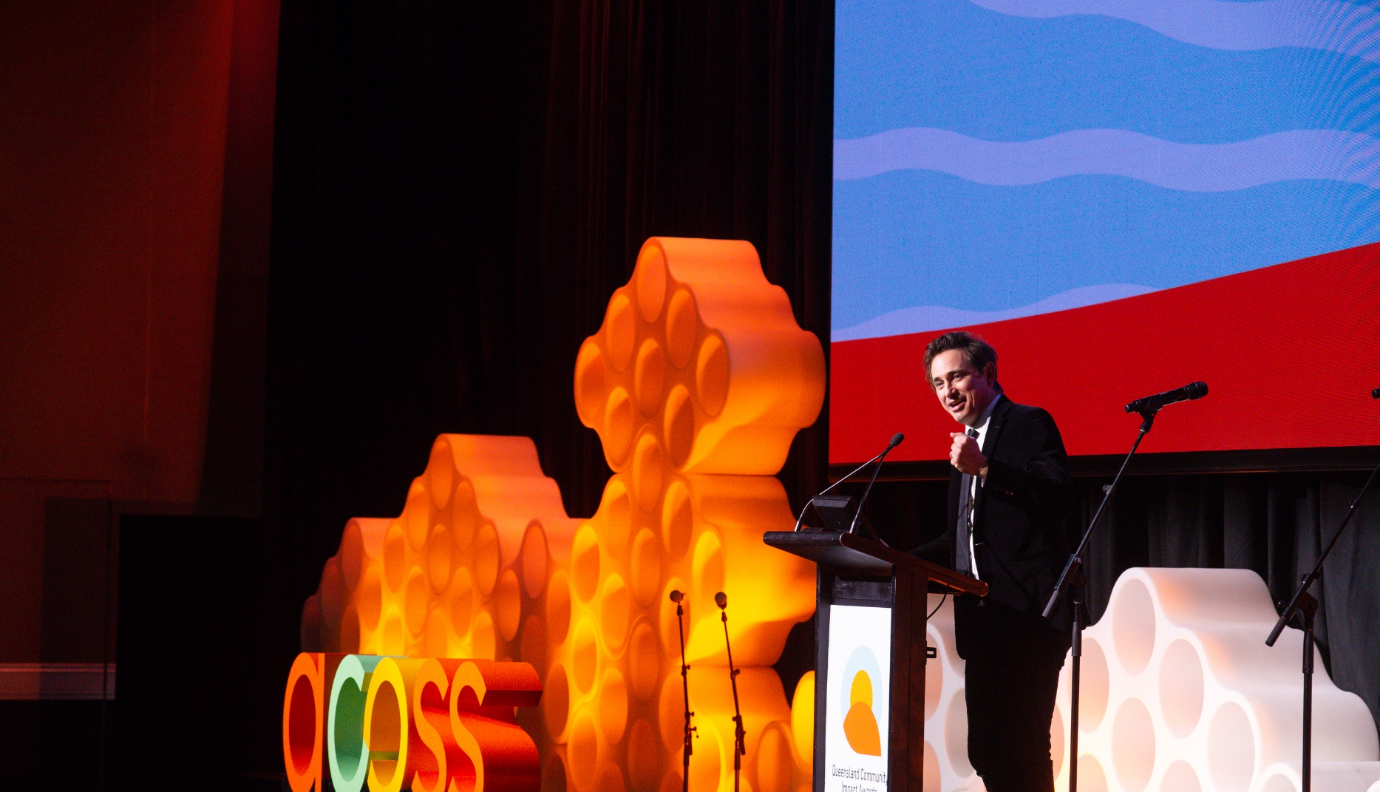
20

Queensland Community Impact Awards (QCIA): The inaugural QCIA celebrated the remarkable and often unacknowledged work of the social service sector. Fifty-five nominations were received across three award categories:

Community Impact:
recognises the extraordinary contribution of an organisation or team in supporting or serving their community
in Queensland.
Frontline Hero:
recognises the extraordinary contribution of a frontline worker in supporting or serving their community
in Queensland.
Human Rights:
recognises the contribution of an organisation or individual
in advancing a human rights respecting culture in Queensland.

The recipients were:

- Multicultural Social Network (Community Impact Award)
- Leanne Papas from Micah Projects (Frontline Hero Award)
- Caxton Legal Centre (Human Rights Impact Award)

The winners were announced at a gala dinner featuring Pride Choir and The Voice grand finalist, Kristal West. The dinner was held on the second night of the QCOSS conference and attended by 250 guests. It was emceed by award winning author, Trent Dalton.

Self-determination of First Nations people
21
Act on opportunities to improve the ability of First Nations
People to realise their right to self-determination.
QCOSS worked towards a Yes vote in the Voice to Parliament
referendum and introduced a cultural capability framework that
underpins key organisational documents.

- Supporting a Yes vote in the Voice to Parliament referendum
QCOSS is an inaugural member of Allies for Uluru, a partnership of more than 200 civil society organisations who have banded together to share ideas about how to ensure a successful Yes vote in the Voice to Parliament referendum. QCOSS CEO Aimee McVeigh attended the Melbourne launch of the coalition in February 2023, as well as subsequent leadership forums.

QCOSS co-hosted the event Host a conversation. Help win a Yes vote in the referendum with Together Yes. Victorian Women’s Trust CEO and Together Yes co-founder Mary Crooks presented on the Kitchen Table Conversation method that she pioneered and discussed how to use it to win a Yes vote in the referendum. 148 people registered to attend the event.

QCOSS disseminated information about the Voice to Parliament referendum to the CEO Network and Peaks Network, at our Town Halls, as well as through our newsletters and social media accounts. We also shared information internally and hosted a Together Yes Kitchen Table Conversation for interested QCOSS staff.

22

- Promoting cultural safety and humility
The community services sector could support healing and reconciliation.
QCOSS partnered with First Nations cultural consultancy organisation W.I.S.E Australia to present the workshops: Cultural Humility and Safety and Trauma and Healing Informed Practice. Each had more than 150 registrants. The workshops addressed the lasting impacts of colonisation on Aboriginal and Torres Strait Islander People, and explored how cultural humility and safety could be used to facilitate better practice for First Nations clients. They also explored how the community services sector could support healing and reconciliation.

- Developing a cultural capability framework
In November 2022, QCOSS engaged BlackCard - a 100% Aboriginal owned and managed
specialist consultancy and training provider - to develop a Cultural Capability Framework.
The purpose of the Framework is to strengthen our working relationships with First Nations Peoples, Aboriginal Community Controlled Organisations, and other key First Nations stakeholders.
The Framework was used to guide the development of QCOSS’ forthcoming Innovate Reconciliation Action Plan.

Walking the talk
23
Be a sustainable and strong organisation that lives our values.
This year, our media reach was in the millions. We continued to
increase our social media presence and we welcomed new members
from across the sector.

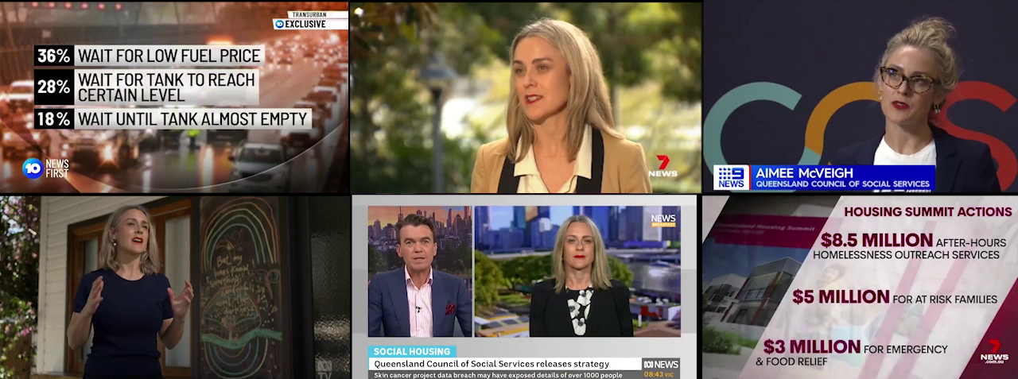

- Ensure QCOSS is a recognised key contributor to public debate
Corporate communications: During 2022-23 there was a notable
increase in engagement with QCOSS’ corporate communications.
- 3,588 media mentions Australia wide
with a projected audience of 57.28 million
- 2,498 Facebook followers
- 3,821 Linked In followers
- 2,313 Twitter (X) followers
- 956 Instagram followers
- 2,846 Conduit newsletter recipients
- 56,591 unique visitors viewed qcoss.org.au 178,170 times.

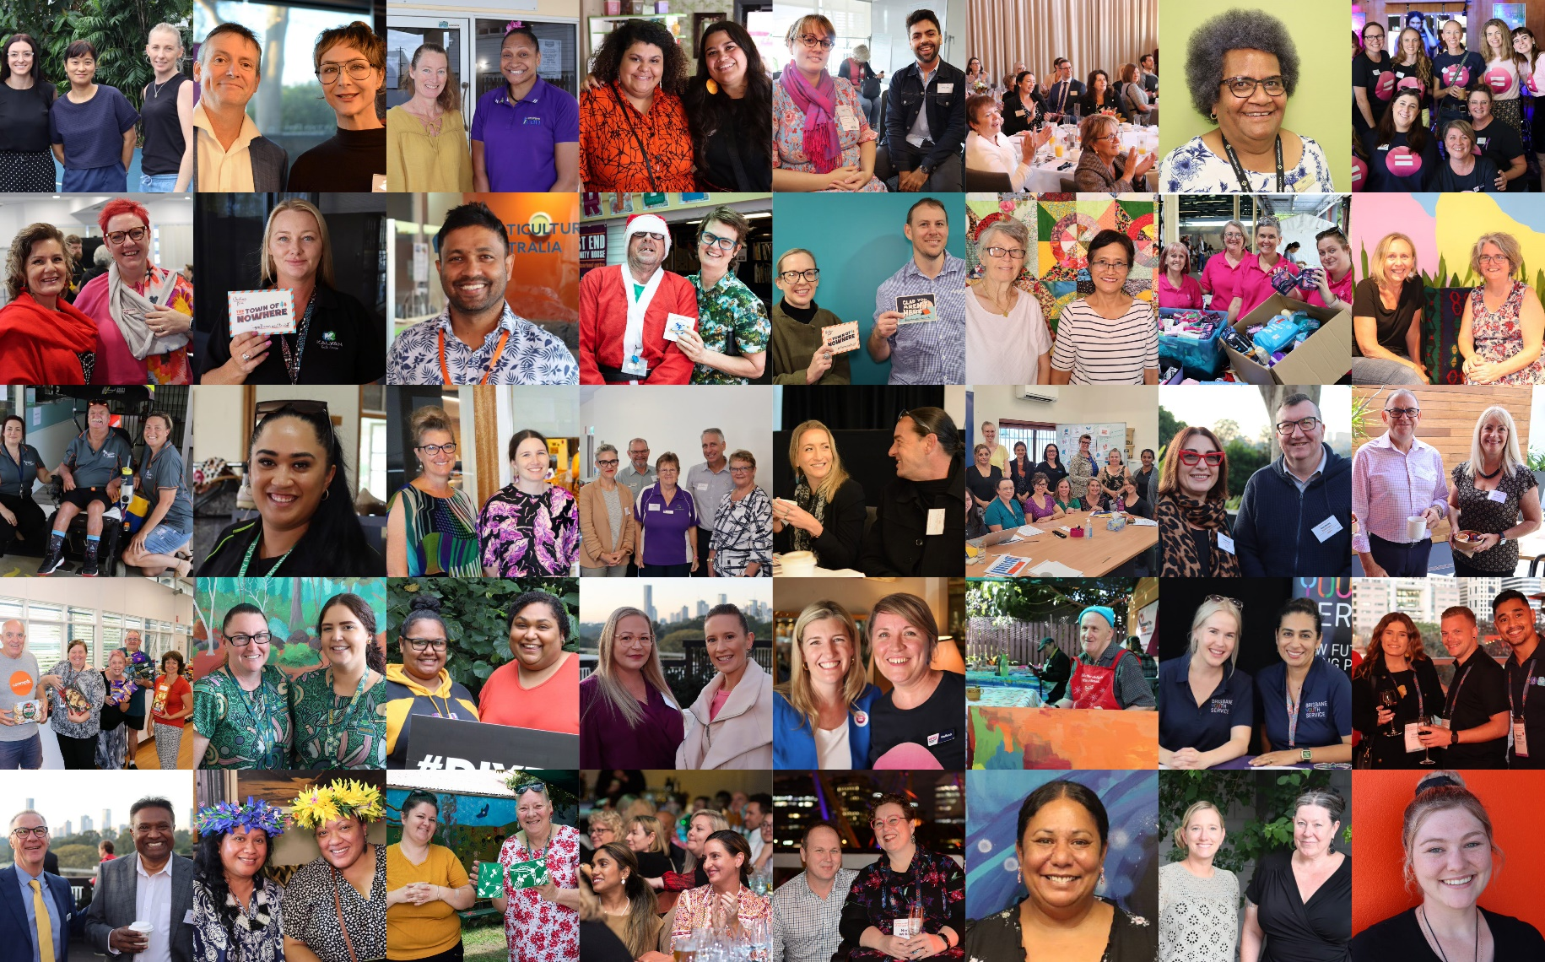
24

- Ensure QCOSS membership is a must have
for community organisations in Queensland
In 2022-23 we worked on deepening our engagement with members and responding to their needs through advocacy, research, policy development, data profiles and capacity building activities. We delivered 31,074 copies of our member e-newsletter, Conduit, and welcomed 67 new members - a total of 461 members altogether. Through our Town Halls and membership networks, our members helped identify, develop, and deliver some of our most impactful advocacy work on housing, indexation and gender responsive budgeting.

- Ensure all team members have what they need to do their job, control and clarity in relation to their work, opportunities to grow and learn and that they feel connected to the purpose of QCOSS
After a month’s long consultation process with QCOSS staff, QCOSS staff union representatives and the Services Union, significant progress was made towards finalising a new Enterprise Bargaining Agreement (EBA) – expected to take effect during the second half of 2023.

During the 2022/23 financial year, we introduced new project management software – Monday Work Management - to ensure the consistent and good practice application of project and contract management across the organisation. Monday also supports resource and workload management, tracking and reporting on the progress of projects, and enhances collaboration and communication across teams. The rollout was further supported by a significant number of employees undertaking the Project Management Body of Knowledge (PMBoK) training.

Meet our Directors
25
The following persons were directors of the company during the whole of the financial year and up to the date of this report, unless otherwise stated:

- Matt Gardiner
- Faiza El-Higzi
- Colleen Tribe
- Kevin Mercer
- Linda McClelland
- Rachelle Patterson (Resigned 10 Nov, 2022)
- Lee-Anne Simpson
- Bronwyn Fredericks
- Alvin Hava
(Appointed 10
Nov, 2022

Board and committee meetings
The Board met nine times during the financial year and made two decisions out of session.
The finance and audit committee met five times and the governance committee met four times.

- Matt Gardiner (Chair)
BSocSc (Couns), M.Clin.Couns., Grad.Dip. Strategic Leadership, MAICD, FIML
Passionate about social justice, improving systems and therapeutic practice, Matt is an experienced practitioner and has held senior executive roles at some of Australia's leading not-for-profits. He currently serves as a director of several companies and governmental advisory committees. He is proud to contribute to the ongoing strength of QCOSS in its strategic objectives and to represent members across the state.
Currently, Matt’s primary role is CEO of 54 reasons (Save The Children’s Australian services division), leading a large, professional workforce across every state and territory. He has a background in relationship and trauma counselling, disability, child protection, mental health, family law mediation, violence prevention and community development. His experience has included several Social Impact Investments, including leading Australia’s first Social Impact Bond to mature, and he has negotiated several innovative Payment By Outcome (PBO), based on risk/return modelling across a range of sectors. Matt has led mergers and acquisitions in several sectors and segments and enjoys leading through cultural and business transformation.

- Faiza El-Higzi OAM
25
BSc (Hons), Grad.Dip Pjt Mgt, MAppSc, MEd. PhD JP(Qual)
Faiza brings over 20 years’ experience in the community sector as a board member, manager, and volunteer, focusing on issues of equity, inclusion and social change.
She is a recipient of the Order of Australia Medal (2020) and Queensland Government Multicultural Award for Outstanding Individual (2018). Faiza is a member of the Queensland Domestic and Family Violence Implementation Council, the Queensland Multicultural Advisory Committee and Metro South Health Consumer Advisory Committee. She is the Chair of the Ethnic Broadcasting Association Queensland.
Faiza worked in strategic policy at both state and federal government. Her experience in the NGO sector includes community development, refugee settlement and youth engagement. Faiza has several qualifications in architecture, project management, international business and education and gender studies. Currently Faiza is an academic with the University of Queensland.

- Colleen Tribe
Dip Ed, B.Ed, Grad Dip Special Ed, Grad Cert Specialised Leadership, MAICD
After serving nearly a decade in the General Manager role at Roseberry Qld (Central Qld region), Colleen is proud of the success she was able to achieve, leading the organisation to the very prominent position it holds within the social sector. Having relocated to Brisbane, Colleen is still focused on ensuring regional issues and interests are highlighted, while serving on the QCOSS Board.
Colleen is currently working in the education sector, where she is able to bring her experience and perspective from the NFP and social sector. Colleen works within the curriculum area and is passionate to ensure best possible outcomes and potential are achieved for our children and young people - our children need great teachers in their lives, to inspire and motivate them.
Having an array of experience on boards, Colleen continues to enjoy working with the talented group of people who sit on the QCOSS Board, as well as management and staff of QCOSS.

- Kevin Mercer
B.Com, MBA, GAICD, FCEOI
Kevin Mercer is the Chief Executive Officer of St Vincent de Paul Society Queensland. He joined in February 2019 with more than 30 years of experience in management across a range of sectors, including 10 years in the aged care, community care, disability and retirement living sectors.
Kevin has also held management positions in marketing, business development and logistics in a range of industries including retail, manufacturing, consulting, telecommunications, and energy sectors.
Kevin has served as the Chief Executive Aged and Community Care of Mercy Health Australia, and as the Chief Executive Officer of Holy Spirit Care Services.
He holds a Bachelor of Commerce in Accountancy and a Master of Business Administration (MBA) from the University of Canterbury. He is a Graduate of the Australian Institute of Company Directors and a Fellow of the CEO Institute of Australia. Kevin has also completed Catholic Health Australia’s Ministry Leadership Program.
He has a strong sense of social justice and a life-long passion for learning to improve the lives of those experiencing disadvantage. Kevin has been a Director of QCOSS since April 2019.
- Linda McClelland
26
B. Arts, Grad Cert in Housing Management & Policy, Advanced Diploma of Community
Sector Management, Diploma of Management, Diploma of Quality Auditing
Linda is a regional member and has worked with and on boards within the not-for-profit sector for over 30 years. As CEO of Hinchinbrook Community Support Centre, she has grown the centre into the lead community service provider in the Hinchinbrook area.
Linda has grown the centre through her passion for empowering others. This manifests in her commitment to teaching and mentoring, having taught community services through TAFE to both senior high school students and Indigenous workers from throughout North and Far North Queensland.
At a strategic level, she has contributed to the development of the sector training, the recognition of Queensland neighbourhood centres through regional and state neighbourhood centres networks, and the needs of the housing sector through the Townsville Housing & Homelessness Network.

- Bronwyn Fredericks
Dip. T(Sec), B.Educ, M.Educ, M.EducStudies, PhD along with two VET
qualifications (Cert IV TAE and a Cert IV in Community Culture)
Bronwyn is a Professor and the Deputy Vice-Chancellor (Indigenous Engagement) at the University of Queensland (UQ). She was previously the Pro Vice-Chancellor (Indigenous Engagement), and before that the Pro Vice-Chancellor (Indigenous Engagement) at Central Queensland University (CQU).
In 2016, Bronwyn was appointed as the Presiding Commissioner with the Queensland Productivity Commission (QPC) to lead the Inquiry into service delivery in Queensland’s remote and discrete Indigenous communities. She worked on the Inquiry into manufacturing, the Inquiry into Imprisonment and Recidivism in Queensland (2019) and the Queensland Recycling Review (2019).
Bronwyn has worked for both state and federal levels of government and has a long history of direct hands-on involvement in Aboriginal and Torres Strait Islander community-based organisations spanning over 30 years. She was Chairperson of the Bidgerdii Community Health Service for some 9 years, a Director of Anglicare Central Queensland, Link-Up (Qld), has assisted in the establishment of community organisations, and served on numerous community committees in Central Queensland, Ipswich, and Brisbane, and at state and national levels.
Bronwyn is a member of the Australian Institute of Aboriginal and Torres Strait Islander Studies (AIATSIS) Research Advisory Committee, the Beyond Blue National Research Advisory Committee, and on numerous other Queensland and national annual awards and policy committees, as well as being a member of the Australian Research Council’s (ARC) College of Experts.
Bronwyn is noted for her community-based research and translating research outcomes along with her strong practice-based commitment to social justice, and improving Indigenous health, education, and life outcomes.

- Lee-Anne Simpson
27
B.Arts, B.Business (Mgmt) (Hons), Graduate Certificate in Management
Lee-Anne is currently a Regional Manager with Carers Queensland delivering Local Area Coordination Services for the National Disability Insurance Scheme across Central Queensland, Sunshine Coast, Gympie and Cooloola and Moreton Bay regions.
Lee-Anne has held several senior management positions across a range of community service organisations and developed partnerships and networks with a diverse range of stakeholders to deliver collaborative projects. She has worked in both service delivery and policy development across a range of project streams including, child protection, domestic and family violence services, family and relationship services and disability services.
Throughout Lee-Anne’s 25-year history working in the community services sector, she remains committed to championing equitable access to services in regional, remote, and rural communities and advocating for community organisations to receive the funding and support they need to deliver them.

- Alvin Hava (appointed 10 November 2022)
B.Applied Health Science (Indigenous Health), Advanced Dipl. Management, and a Cert IV in
Youth Work, Indigenous Primary Health Care, Assessment and Training and Mental Health
Alvin is the General Manager of Mithangkaya Nguli Young People Ahead Youth and Community Services Indigenous Corporation, based on Kalkadoon Nation in the mining city of Mount Isa, and has been in this role for more than 12 years.
Alvin has a career spanning over 30 years working in the social health and community services sector, with a passion for working with First Nation children, youth and their families to address underlying social determinants to health and wellbeing.
Alvin was previously a Board Director at several Queensland peak bodies, namely the Workforce Health and Community Council, the Youth Affairs Network of Queensland, and more recently with the Queensland Youth Housing Coalition. Alvin is committed to ensuring children and young people’s voices are heard, and that true commitments to have them involved in important decision making are adhered to and valued, as they are the future leaders of Australia.

- Rachelle Patterson (resigned 10 November 2022)
B.Psychology, M.Suicidology, Master of Health Promotion
Rachelle is the Chief Executive Officer with Lifeline Darling Downs and South West Queensland Limited. She believes that every person has the right to be safe, heard and thriving.
Rachelle has held several executive and frontline positions across out-of-home care, mental health, suicidology, criminology and human services. She has worked in urban, regional and remote settings across Queensland, NSW, ACT and Western Australia.
Rachelle’s work across rural and remote Australia has taught her that best practice and evidence-based models are not always a good fit for their intended populations. Rachelle is passionate about getting service providers and funding bodies to develop and deliver responsive programs and models that respond to the needs of the community and the individual.

Funders and Supporters
28

Thanks to every QCOSS member in every community in Queensland. Without your support we could not even begin to strive for our vision.
Thanks also to our funders and supporters.

Project funders

- Department of Communities, Housing and Digital Economy
- Department of Child Safety, Senior and Disability Services
- Department of Employment, Small Business and Training
- Gold Coast Homeless Network Inc
- Department of Regional Development, Manufacturing and Water
- Department of Energy and Public Works, Energy Division
- Department of Children, Youth Justice and Multicultural Affairs
- Department of Communities, Housing and Digital Economy – Housing
- Change the Record c/o ANTAR Incorporated
- Swinburne University of Technology

Sponsors

2022 QCOSS Conference:
Power and Politics of the Care Economy
- Q Shelter
- Queensland Human Rights Commission
- Clayton Utz
- InfoXchange
- Relationships Australia Queensland
- Kurbingui Youth and Family Development
- Windsor Recruitment
- Quality Innovation Performance Limited
- Basic Rights Queensland
- Anacta Strategies
- Wesley Mission Queensland
- QUT Centre for Justice
- Gold Coast Youth Service
Queensland Community Impact Awards 2022
- Clayton Utz
- RACQ Foundation
- Queensland Human Rights Commission

QCOSS Budget Breakfast (June 2023)
- Hesta
- Infoxchange
- Windsor Group

In Conversation event series
- QUT Centre for Justice

Town of Nowhere founding partners
29

- 54 reasons
- Aboriginal Torres Strait Islander Housing Queensland
- Anglicare Central Queensland
- Anglicare North Queensland
- Anglicare Southern Queensland
- Brisbane Youth Service
- Catholic Care Social Services - Toowoomba Region
- Centacare Central Queensland
- Community and Specialist Support Inc (CASSI)
- DVConnect
- Footprints Community
- Kyabra Community Association
- Lifeline Darling Downs and South West Queensland Ltd
- Queensland Meals on Wheels
- Micah Projects
- Mission Australia
- Q Shelter
- St Vincent de Paul Society Queensland
- UnitingCare Community
- Wesley Mission Queensland
- YFS

Pro-bono professional support and advice
- Clayton Utz
- Hall and Wilcox
- BDO

30

Financials
2023

 | Notes | 2023 | 2022
 |  | $ | $
Revenue | 2 | 4,390,125 | 3,737,121*
Employee benefits |  | (2,887,498) | (2,878,018)
Depreciation and amortisation | 3 | (158,675) | (153,376)
Loss on Investments | 3 | - | (152,395)
Computer costs |  | (88,467) | (40,701)
Conference/seminar costs |  | (300,557) | (31,347)
Consultancy fees |  | (228,848) | (122,915)
Travel and accommodation |  | (74,621) | (35,457)
Printing and stationery |  | (23,923) | (26,908)
Rent | 3 | (1,863) | (1,853)
Postage |  | (528) | (605)
Telephone |  | (20,888) | (15,314)
Other expenses |  | (343,048) | (246,140)
Surplus before income tax expense |  | 261,209 | 32,092
Income tax expense | 1 | - | -
Surplus after income tax expense for the year |  | 261,209 | 32,092

QUEENSLAND COUNCIL OF SOCIAL SERVICE LTD
STATEMENT OF PROFIT OR LOSS AND OTHER COMPREHENSIVE INCOME
FOR THE YEAR ENDED 30 JUNE 2023

31
Other comprehensive loss for the year, net of tax |  | - | -
Total comprehensive income for the year |  | 261,209 | 32,092
* Revenue includes restricted donations, refer note 2 for details.

The accompanying notes form part of these financial statements

 | Notes | 2023 | 2022
 |  | $ | $
CURRENT ASSETS
Cash and cash equivalents | 4 | 1,794,156 | 1,638,533
Trade receivables | 5 | 238,854 | 189,063
Other current assets | 6 | 12,329 | 43,906
TOTAL CURRENT ASSETS |  | 2,045,339 | 1,871,502
NON-CURRENT ASSETS
Property, plant and equipment | 8 | 18,503 | 16,706
Right of use Assets | 11 | 322,850 | 467,205
Investments | 7 | 1,880,738 | 1,503,752
TOTAL NON-CURRENT ASSETS |  | 2,222,091 | 1,987,663
TOTAL ASSETS |  | 4,267,430 | 3,859,165
CURRENT LIABILITIES
Trade and other payables | 9 | 1,639,252 | 1,354,512
Lease Liabilities | 11 | 106,620 | 141,016
TOTAL CURRENT LIABILITIES |  | 1,745,872 | 1,495,528
NON-CURRENT LIABILITIES
Long-term provisions | 10 | 24,149 | 17,491
Lease Liabilities | 11 | 243,431 | 353,377
TOTAL NON-CURRENT LIABILITIES |  | 267,580 | 370,868
TOTAL LIABILITIES |  | 2,013,452 | 1,866,396
NET ASSETS |  | 2,253,978 | 1,992,769
EQUITY
Social Housing reserve |  | 159,920 | 183,801
Retained surpluses |  | 2,094,058 | 1,808,968
TOTAL EQUITY |  | 2,253,978 | 1,992,769

QUEENSLAND COUNCIL OF SOCIAL SERVICE LTD
STATEMENT OF FINANCIAL POSITION
AS AT 30 JUNE 2023

32

The accompanying notes form part of these financial statements
QUEENSLAND COUNCIL OF SOCIAL SERVICE LTD
STATEMENT OF CHANGES IN EQUITY
FOR YEAR ENDED 30 JUNE 2023
33
 |  |  | Retained surpluses | Social housing reserve | Total
 |  |  | $ |  | $
Balance as at 1 July 2021 |  |  | 1,960,678 | - | 1,960,678
Surplus after income tax expense for the year |  |  | 32,092 | - | 32,092
Other Comprehensive Income, net of tax |  |  | - | - | -
Total Comprehensive Income |  |  | 32,092 | - | 32,092
Transfers from retained earnings to reserve – Note 17 |  |  | (183,801) | 183,801 | -
Balance as at 30 June 2022 |  |  | 1,808,968 | 183,801 | 1,992,769
Balance as at 1 July 2022 |  |  | 1,808,968 | 183,801 | 1,992,769
Surplus after income tax expense for the year |  |  | 261,209 | - | 261,209
Other Comprehensive Income, net of tax |  |  | - | - | -
Total Comprehensive Income |  |  | 261,209 | - | 261,209
Transfers from retained earnings to reserve – Note 17 |  |  | 23,881 | (23,881) | -
Balance as at 30 June 2023 |  |  | 2,094,058 | 159,920 | 2,253,978

The accompanying notes form part of these financial statements

 | Notes | 2023 | 2022
 |  | $ | $
CASH FLOW FROM OPERATING ACTIVITIES
Receipts from government grants, members, and clients |  | 4,284,740 | 3,908,839
Payments to suppliers and employees |  | (3,728,002) | (3,428,902)
Interest received |  | 5,293 | 1,736
Net cash provided by/ (used in) operating activities | 14(b) | 562,031 | 481,673
CASH FLOW FROM INVESTING ACTIVITIES
Payment for property, plant, and equipment |  | (16,117) | (43,071)
Payment for investments |  | (245,947) | -
Proceeds from investments |  | - | 72,999
Net cash provided by/ (used in) investing activities |  | (262,064) | 29,928
CASH FLOW FROM FINANCING ACTIVITIES
Repayment of Leases |  | (144,344) | (91,003)
Net cash provided by/ (used in) financing activities |  | (144,344) | (91,003)
Net increase/(decrease) in cash and cash equivalents |  | 155,623 | 420,597
Cash at beginning of financial year |  | 1,638,533 | 1,217,935
Cash at end of financial year | 14(a) | 1,794,156 | 1,638,533
QUEENSLAND COUNCIL OF SOCIAL SERVICE LTD
STATEMENT OF CASH FLOWS
FOR YEAR ENDED 30 JUNE 2023

34

The accompanying notes form part of these financial statements

NOTE 1: STATEMENT OF SIGNIFICANT ACCOUNTING POLICIES

General information
The financial statements cover Queensland Council of Social Service Ltd, a not-for-profit unlisted public company limited by guarantee, incorporated, and domiciled in Australia. The financial statements are presented in Australian dollars, which is the company’s functional and presentation currency. Its registered office and principal place of business are:
Ground Floor
20 Pidgeon Close
West End Qld 4101

A description of the nature of the company’s operations and its principal activities are included in the directors’ report, which is not part of the financial statements.
The financial statements were authorised for issue, in accordance with a resolution of directors, on __ September 2023. The directors have the power to amend and reissue the financial statements.

Basis of preparation
These general-purpose financial statements have been prepared in accordance with Australian Accounting Standards – Simplified Disclosures issued by the Australian Accounting Standards Board (‘AASB’), the Australian Charities and Not for Profits Commission Act 2012(ACNC 2012), as appropriate for not-for-profit oriented entities.

Historical cost convention
QUEENSLAND COUNCIL OF SOCIAL SERVICE LTD
NOTES TO THE FINANCIAL STATEMENT
FOR YEAR ENDED 30 JUNE 2023
35
The financial statements have been prepared under the historical cost convention.
Revenue
Revenue is recognised when control of a promised good or service is passed to the customer at an amount which reflects the expected consideration. If there is no enforceable agreement in place or no sufficiently specific performance obligations, revenue is recognised when the consideration is received.
Membership Income
Membership subscriptions are levied on the company’s members. The income is recognised in the period to which it relates. Membership income received in advance is recognised in the statement of financial position as membership fees received in advance.
Donations
Donations are recognised at the time the revenue is received.
Grants from Government Departments
Specific purpose funding arrangements from government departments require funds to be used for specific objectives, outcomes, outputs and performance benchmarks or milestones related to the delivery of specific projects and improvements in service delivery or reform. Where these arrangements are determined to be enforceable through legal or equivalent means and contain sufficiently specific obligations relating to the delivery of goods and services, revenue would be recognised in accordance with AASB 15. If such funding does not meet the ‘sufficiently specific’ and ‘enforceability’ criteria of AASB 15, income is recognised under AASB 1058 when the recipient entity controls the cash.

NOTE 1: STATEMENT OF SIGNIFICANT ACCOUNTING POLICIES (CONT’D)
QUEENSLAND COUNCIL OF SOCIAL SERVICE LTD
NOTES TO THE FINANCIAL STATEMENT
FOR YEAR ENDED 30 JUNE 2023
36
Deferred Income
Deferred income represents grants received in advance for next financial year or unexpended grants recognised under AASB 15, which under the terms of agreement with the grantors, are refundable or have performance conditions which are not yet satisfied.
Interest
Interest revenue is recognised as interest accrues using the effective interest method.
Other revenue
Other revenue is recognised when it is received or when the right to receive payment is established.
Income Tax
As the company is a charitable institution in terms of subsection 50-5 of the Income Tax Assessment Act 1997, as amended, it is exempt from paying income tax.
Current and non-current classification
Assets and liabilities are presented in the statement of financial position based on current and non-current classification.
An asset is current when: it is expected to be realised or intended to be sold or consumed in normal operating cycle; it is held primarily for the purpose of trading; it is expected to be realised within twelve months after the reporting period; or the asset is cash or cash equivalent unless restricted from being exchanged or used to settle a liability for at least twelve months after the reporting period. All other assets are classified as non-current.
A liability is current when: it is expected to be settled in normal operating cycle; it is held primarily for the purpose of trading; it is due to be settled within twelve months after the reporting period; or there is no unconditional right to defer the settlement of the liability for at least twelve months after the reporting period. All other liabilities are classified as non-current.
Cash and Cash Equivalents
Cash and cash equivalents includes cash on hand, deposits held at call with financial institutions, other short-term, highly liquid investments with original maturities of six months or less that are readily convertible to known amounts of cash and which are subject to an insignificant risk of changes in value.
Trade and other receivables
Trade receivables are initially recognised at fair value and subsequently measured at amortised cost using the effective interest method, less any allowance for expected credit losses. Trade receivables are generally due for settlement within 30 days.
Impairment
The company applies the simplified approach permitted by AASB 9, which requires expected lifetime losses to be recognised from initial recognition of the receivables. Management has determined that assessment of expected credit loss associated with trade receivables is immaterial.
Plant, plant, and equipment
Plant and equipment is stated at historical cost less accumulated depreciation and impairment. Historical cost includes expenditure that is directly attributable to the acquisition of the items.
Depreciation is calculated on a straight-line basis to write off the net cost of each item of property, plant and equipment over their expected useful lives as follows:
Class of fixed asset Useful lives Depreciation basis
Office Equipment 4 to 5 years Straight Line
Furniture, Fixtures and Fittings 10 years Straight Line

NOTE 1: STATEMENT OF SIGNIFICANT ACCOUNTING POLICIES (CONT’D)
37
The residual values, useful lives and depreciation methods are reviewed, and adjusted if appropriate, at each reporting date.
An item of property, plant and equipment is de-recognised upon disposal or when there is no future economic benefit to the Company. Gains and losses between the carrying amount and the disposal proceeds are taken to profit or loss.
(g) Impairment of non-financial assets
Non-financial assets are reviewed for impairment whenever events or changes in circumstances indicate that the carrying amount may not be recoverable. An impairment loss is recognised for the amount by which the asset’s carrying amount exceeds its recoverable amount.
(h) Trade and other payables
These amounts represent liabilities for goods and services provided to the company prior to the end of the financial year and which are unpaid. Due to their short-term nature, they are measured at amortised cost and are not discounted. The amounts are unsecured and are usually paid within 30 days of recognition.
(i) Employee Benefits
Short-term employee benefits
Liabilities for wages and salaries, including non-monetary benefits, annual leave and long service leave expected to be settled within 12 months of the reporting date are recognised in current liabilities in respect of employees’ services up to the reporting date and are measured at the amounts expected to be paid when the liabilities are settled.
Other long-term employee benefits
The liability for annual leave and long service leave not expected to be settled within 12 months of the reporting date are recognised in non-current liabilities, provided there is an unconditional right to defer settlement of the liability. The liability is measured as the present value of expected future payments to be made in respect of services provided by employees up to the reporting date using the projected unit credit method. Consideration is given to expected future wage and salary levels, experience of employee departures and periods of service. Expected future payments are discounted using market yields at the reporting date on national government bonds with terms to maturity and currency that match, as closely as possible, the estimated future cash outflows.
(j) Fair value measurement
When an asset or liability, financial or non-financial, is measured at fair value for recognition or disclosure purposes, the fair value is based on the price that would be received to sell an asset or paid to transfer a liability in an orderly transaction between market participants at the measurement date; and assumes that the transaction will take place either: in the principle market; or in the absence of a principle market, in the most advantageous market.
Fair value is measured using the assumptions that market participants would use when pricing the asset or liability, assuming they act in their economic best interest. For non-financial assets, the fair value measurement is based on its highest and best use. Valuation techniques that are appropriate in the circumstances and for which sufficient data are available to measure fair value, are used, maximising the use of relevant observable inputs, and minimising the use of unobservable inputs.
QUEENSLAND COUNCIL OF SOCIAL SERVICE LTD
NOTES TO THE FINANCIAL STATEMENT
FOR YEAR ENDED 30 JUNE 2023

- Goods and Services Tax (GST) and other similar taxes
QUEENSLAND COUNCIL OF SOCIAL SERVICE LTD
NOTES TO THE FINANCIAL STATEMENT
FOR YEAR ENDED 30 JUNE 2023
38
Revenues, expenses, and assets are recognised net of the amount of associated GST, unless the GST incurred is not recoverable from the tax authority. In this case it is recognised as part of the cost of the acquisition of the asset or as part of the expense.
Receivables and payables are stated inclusive of the amount of GST receivable or payable. The net amount of GST recoverable from, or payable to, the tax authority is included in other receivables or other payables in the statement of financial position.

NOTE 1: STATEMENT OF SIGNIFICANT ACCOUNTING POLICIES (CONT’D)
Cash flows are presented on a gross basis. The GST components of cash flows arising from investing or financing activities which are recoverable from, or payable to the tax authority, are presented as operating cash flows.
Commitments and contingencies are disclosed net of the amount of GST recoverable from, or payable to, the tax authority.
- Leases
The Company leases office, equipment, and vehicle. Rental contracts are typically made for fixed periods of 1 to 5 years but may have extension options. Lease terms are negotiated on an individual basis and contain a wide range of different terms and conditions. The lease agreements do not impose any covenants other than the security interests in the leased assets that are held by the lessor.
Leases are recognised as a right-of-use asset and a corresponding liability at the date at which the leased asset is available for use by the Company.
Assets and liabilities arising from a lease are initially measured on a present value basis.
Lease liabilities include the net present value of the following lease payments:
- Fixed payments (including in-substance fixed payments), less any lease incentives receivable;
- Variable lease payment that are based on an index or a rate, initially measured using the index or rate as at the commencement date;
- The exercise price of a purchase option if the Company is reasonably certain to exercise that option; and
- Payments of penalties for terminating the lease, if the lease term reflects the Company exercising that option.
- Any initial direct costs, and
- Restoration costs.
Right-of-use assets are generally depreciated over the shorter of the asset’s useful life and the lease term on a straight-line basis. If the Company is reasonably certain to exercise a purchase option, the right-of-use asset is depreciated over the underlying asset’s useful life.
- Critical Accounting Estimates and Judgments
The preparation of the financial statements requires the use of certain critical accounting estimates. It also requires management to exercise its judgement in the process of applying the company’s accounting policies. The areas involving a higher degree of judgement or complexity, or areas where assumptions and estimates are significant to the financial statements.
Estimation of useful lives of assets
The company determines the estimated useful lives and related depreciation and amortisation charges for its property, plant and equipment and finite life intangible assets. The useful lives could change significantly as a result of technical innovations or some other event. The depreciation and amortisation charge will increase where the useful lives are less than previously estimated lives, or technically obsolete or non-strategic assets that have been abandoned or sold will be written off or written down.

NOTE 2: REVENUE
39
 |  | 2023  $ | 2022  $
Operating activities
QCOSS project funding |  | 3,167,574 | 3,052,507
Membership Income |  | 436,221 | 311,200
Other income |  | 434,997 | 141,178
Social Housing Campaign Funding – Restricted* |  | 215,000 | 230,500
 |  | 4,253,792 | 3,735,385
Non-operating activities
Interest |  | 5,293 | 1,736
Gain on Investments |  | 131,040 | -
 |  | 4,390,125 | 3,737,121

*Relates to donations received in relation to the social housing Town of Nowhere campaign commenced in 2022 which will run over a period of three years. Expenditure during the year relating to social housing Town of Nowhere campaign was $240,201 (2022: $46,699).

Revenue from government sources:
 |  | 2023  $ | 2022  $
State government
Department of Energy and Public Works |  | 284,713 | 221,104
Department of Child Safety, Seniors and Disability Services |  | - | 930,468
Department of Children, Youth Justice and Multicultural Affairs |  | 197,404 | 70,076
Department of Communities, Housing and Digital Economy |  | 1,734,642 | 1,090,083
Department of Employment, Small Business and Training |  | 375,770 | 150,000
Department of Regional Development, Manufacturing and Water |  | 147,319 | 98,289
Non-government project funding |  | 427,726 | 492,487
 |  | 3,167,574 | 3,052,507
The Company is dependent on receiving government grants for most of its revenue used to operate the business. At the date of this report the directors have no reason to believe the Company will not continue to receive grants from the government.

QUEENSLAND COUNCIL OF SOCIAL SERVICE LTD
NOTES TO THE FINANCIAL STATEMENT
FOR YEAR ENDED 30 JUNE 2023

NOTE 3: EXPENSES
QUEENSLAND COUNCIL OF SOCIAL SERVICE LTD
NOTES TO THE FINANCIAL STATEMENT
FOR YEAR ENDED 30 JUNE 2023
40
 |  | 2023  $ | 2022  $
Surplus before income tax includes the following specific expenses:
Depreciation and amortisation of non-current assets |  | 158,675 | 153,376
Loss on Investments |  | - | 152,395

NOTE 4: CASH AND CASH EQUIVALENTS
 |  | 2023  $ | 2022  $
Cash on hand |  | 189 | 8
Cash at bank* |  | 1,744,594 | 1,589,152
Deposits at call |  | 49,373 | 49,373
 |  | 1,794,156 | 1,638,533
* Cash at bank includes restricted cash of $159,920 (2022: $183,801) relating to the social housing Town of Nowhere campaign which will run over a period of three years.

NOTE 5: TRADE RECEIVABLES
 |  | 2023  $ | 2022  $
Trade receivables |  | 238,854 | 189,063

NOTE 6: OTHER CURRENT ASSET
 |  | 2023  $ | 2022  $
Prepayments and other receivable |  | 12,329 | 43,906

NOTE 7: INVESTMENTS
41
Non-Current |  | 2023  $ | 2022  $
Financial Assets at Fair Value through Profit or Loss |  | 1,880,738 | 1,503,752

NOTE 8: PLANT AND EQUIPMENT
 |  | 2023  $ | 2022  $
PROPERTY, PLANT AND EQUIPMENT
(a) Office equipment
At cost |  | 122,755 | 111,958
Less accumulated depreciation |  | (104,253) | (95,252)
 |  | 18,503 | 16,706
(b) Office furniture and fittings
At cost |  | 14,229 | 14,229
Less accumulated depreciation |  | (14,229) | (14,229)
 |  | - | -
Total property, plant, and equipment |  | 18,503 | 16,706

Reconciliation
Movement in the carrying amounts for each class of property, plant and equipment between the beginning and the end of the current financial year.
 |  | Furniture  and Fittings | Office Equipment | Total
2023 |  | $ | $ | $
Balance at the beginning of the year |  | - | 16,706 | 16,706
Additions - cost |  | - | 10,798 | 10,798
Depreciation expense |  | - | (9,001) | (9,001)
Carrying amount at end of year |  | - | 18,503 | 18,503

2022 |  | $ | $ | $
Balance at the beginning of the year |  | - | 23,560 | 23,560
Additions - cost |  | - | 7,038 | 7,038
Depreciation expense |  | - | (13,892) | (13,892)
Carrying amount at end of year |  | - | 16,706 | 16,706

QUEENSLAND COUNCIL OF SOCIAL SERVICE LTD
NOTES TO THE FINANCIAL STATEMENT
FOR YEAR ENDED 30 JUNE 2023

NOTE 9: TRADE AND OTHER PAYABLES
QUEENSLAND COUNCIL OF SOCIAL SERVICE LTD
NOTES TO THE FINANCIAL STATEMENT
FOR YEAR ENDED 30 JUNE 2023
42
 |  | 2023  $ | 2022  $
Trade payables |  | 14,450 | 13,230
GST Payable |  | 69,469 | 103,921
Annual leave |  | 256,426 | 238,923
Accrued expenses |  | 290,638 | 147,253
Long service and other leave |  | 72,902 | 59,015
Deferred grant income |  | 595,246 | 466,846
Memberships received in advance |  | 254,650 | 234,283
Other income received in advance |  | 85,471 | 91,041
 |  | 1,639,252 | 1,354,512

NOTE 10: PROVISIONS
 |  | 2023  $ | 2022  $
NONCURRENT
Employee entitlements – Long service leave |  | 24,149 | 17,491

NOTE 11: RIGHT-OF-USE ASSETS AND LEASE LIABILITY
Right-of-use Assets |  | 2023  $ | 2022  $
Leased building – right-of-use |  | 669,790 | 669,790
Accumulated amortisation – Leased Buildings |  | (368,683) | (234,725)
Total Leased Building |  | 301,107 | 435,065
Motor Vehicle |  | 50,176 | 45,574
Accumulated amortisation – Motor Vehicle |  | (28,433) | (13,434)
Total Motor Vehicle |  | 21,473 | 32,140
Total Right-Of-use Assets |  | 322,850 | 467,205

Lease liabilities |  | 2023  $ | 2022  $
CURRENT
Leases for building premise |  | 95,604 | 130,892
Leases for vehicle |  | 11,016 | 10,124
 |  | 106,620 | 141,016

NOTE 11: RIGHT-OF-USE ASSETS AND LEASE LIABILITY (CONT’D)
43
Lease liabilities |  | 2023  $ | 2022  $
NON-CURRENT
Leases for building premise |  | 231,156 | 330,493
Leases for vehicle |  | 12,285 | 22,884
 |  | 243,431 | 353,377

Reconciliation
Movement in the carrying amounts for each class of right of use assets between the beginning and the end of the current financial year.
 |  | Premises | Motor Vehicle | Total
2023 |  | $ | $ | $
Balance at the beginning of the year |  | 435,065 | 32,140 | 467,205
Additions |  | - | 5,319 | 5,319
Amortisation expense |  | (133,958) | (15,716) | (149,674)
Carrying amount at end of year |  | 301,107 | 21,743 | 322,850

NOTE 12: CONTINGENT LIABILITY
The company has a bank guarantee of $49,373 that relates to the lease agreement at 20 Pidgeon Close, which is secured by a term deposit. There are no other contingent liabilities.

NOTE 13: RELATED PARTY TRANSACTIONS
There were no related party transactions during 2023 financial year or in the prior year.
Key management personnel – disclosures relating to key management personnel are set out in note 15.

QUEENSLAND COUNCIL OF SOCIAL SERVICE LTD
NOTES TO THE FINANCIAL STATEMENT
FOR YEAR ENDED 30 JUNE 2023

NOTE 14: CASH FLOW INFORMATION
QUEENSLAND COUNCIL OF SOCIAL SERVICE LTD
NOTES TO THE FINANCIAL STATEMENT
FOR YEAR ENDED 30 JUNE 2023
444
 |  | 2023  $ | 2022  $
- Reconciliation of cash
Cash at the end of the financial year as shown in the cash flow statement is reconciled to the related items in the balance sheet as follows:
Cash on hand |  | 189 | 8
Cash at bank |  | 1,744,594 | 1,589,152
At call deposits with financial institutions |  | 49,373 | 49,373
 |  | 1,794,156 | 1,638,533

NOTE 14: CASH FLOW INFORMATION (CONT’D)
 |  | 2023  $ | 2022  $
- Reconciliation of cash flow from operations
with surplus after income tax
Surplus after income tax expense |  | 261,209 | 32,092
Non-cash flows in surplus:
Depreciation |  | 158,675 | 153,376
Fair value (increase) / decrease in investments |  | (131,040) | 152,395
Changes in assets and liabilities:
Decrease/(increase) in receivables |  | (49,791) | (78,945)
Decrease/(increase) in other current assets |  | 31,666 | 588
Increase/(decrease) in payables |  | 1,220 | (59,370)
Increase/(decrease) in accruals and provisions |  | 209,353 | 29,138
Increase/ (decrease) in deferred income |  | 80,739 | 252,399
Cash flows from operations |  | 562,031 | 481,673

NOTE 15. KEY MANAGEMENT PERSONNEL DISCLOURES
Compensation
The aggregate compensation made to the members of key
management personnel of the Company is set out below:
 |  |  |  |  |  | 2023 | 2022
 |  |  |  |  |  | $ | $
Short-term employee benefits |  |  |  |  |  | 671,078 | 697,513
Long-term benefits |  |  |  |  |  | 7,607 | 11,383
Post-employment benefits |  |  |  |  |  | 76,032 | 76,522
 |  |  |  |  |  | 754,717 | 785,418
Related party transactions
Related party transactions are set out in note 13.
454

NOTE 16. REMUNERATION OF AUDITORS
During the financial year the following fees were paid or
payable for services provided by BDO Audit Pty Ltd:
 |  |  |  | 2023  $ |  | 2022  $
Audit of the financial statements |  |  |  | 29,000 |  | 36,750

NOTE 17. SOCIAL HOUSING RESERVE
 |  | 2023  $ | 2022  $
Reconciliation of social housing reserve
Opening balance | 183,801 |  | -
Receipt of donations during the year | 216,320 |  | 230,500
Expenditure during the year | (240,201) |  | (46,699)
Net movement for the year | (23,881) |  | 183,801
Closing balance | 159,920 |  | 183,801

During 2022 QCOSS partnered with its member-based organisations to become founding partners and raise funds to be part of the social housing Town of Nowhere 2.0 campaign to build sustained public support and a political environment for governments to make major investments into social housing and to enact legislative reforms over a period of three years. The reserve relates to the funds received which will be spent over three years.
QUEENSLAND COUNCIL OF SOCIAL SERVICE LTD
NOTES TO THE FINANCIAL STATEMENT
FOR YEAR ENDED 30 JUNE 2023

NOTE 18: EVENTS SUBSEQUENT TO BALANCE DATE
QUEENSLAND COUNCIL OF SOCIAL SERVICE LTD
NOTES TO THE FINANCIAL STATEMENT
FOR YEAR ENDED 30 JUNE 2023
464
There are no material events after 30 June 2023 requiring disclosure.

In the directors' opinion:
the attached financial statements comprising the statement of profit or loss and other comprehensive income, statement of financial position, statement of changes in equity and statement of cashflows and accompany notes, are in accordance with the Australian Charities and Not for Profits Commission Act 2012;
comply with Australian Accounting Standards – Simplified Disclosures and the Australian Charities and Not for Profits Commission Regulation 2013(ACNC Regulation 2013);
the attached financial statements and notes thereto give a true and fair view of the company's financial position as at 30 June 2023 and of its performance for the financial year ended on that date; and
there are reasonable grounds to believe that the company will be able to pay its debts as and when they become due and payable.
Signed in accordance with a resolution of directors made pursuant to subsection 60.15(2) of the ACNC Regulation 2013.
On behalf of the directors

________________________________
Chair
Brisbane

Brisbane, 21 September 2023
QUEENSLAND COUNCIL OF SOCIAL SERVICE LTD
DIRECTORS DECLARATION
474

