QCOSS Annual Report
July 2021 - June 2022

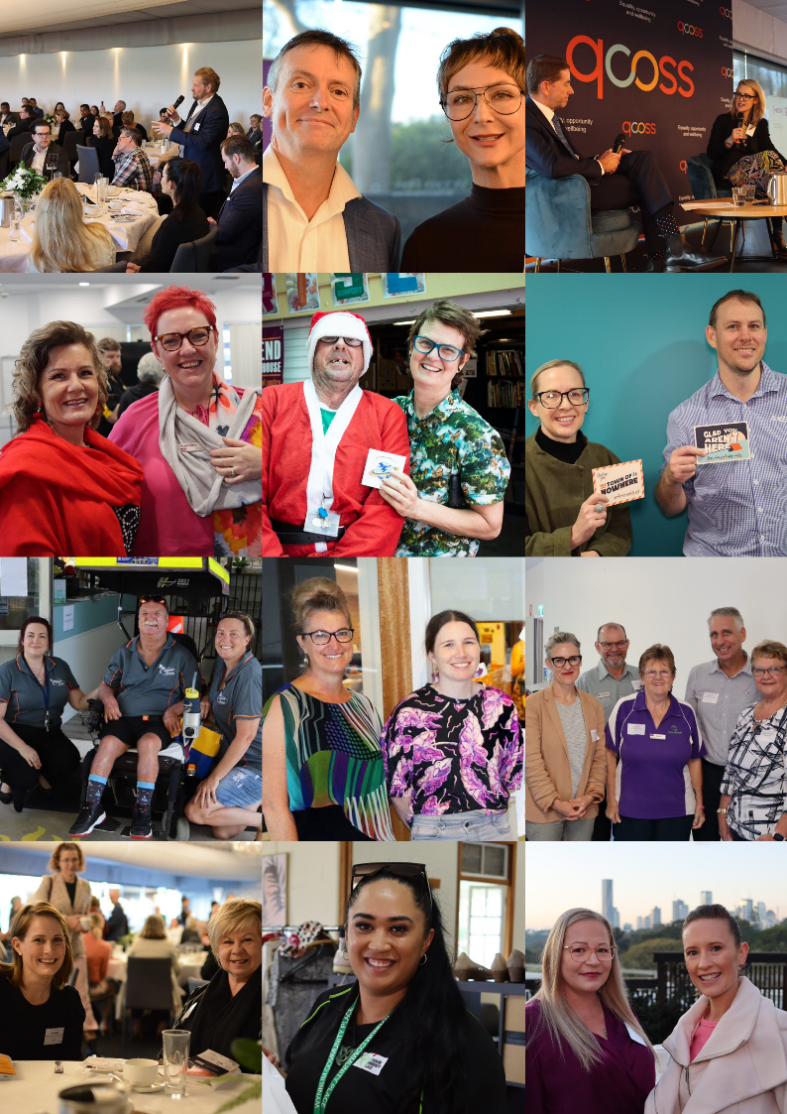

QCOSS acknowledges Aboriginal and Torres Strait Islander people as the original inhabitants of Australia and recognises these unique cultures as part of the cultural heritage of all Australians. We pay respect to the Elders of this land; past and present

© 2022 Queensland Council of Social Service Ltd. This publication is copyright
About QCOSS

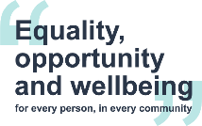
We are QCOSS (Queensland Council of Social Service), Queensland’s peak body for the social service sector.
Our vision is to achieve equality, opportunity and wellbeing for every person, in every community.
We believe that every person in Queensland – regardless of where they come from, who they pray to, their gender, who they love, how or where they live – deserves to live a life of equality, opportunity and wellbeing.
We are a conduit for change. We bring people together to help solve the big social issues
faced by people in Queensland, building strength in numbers to amplify our voice.
We’re committed to self-determination and opportunity for Aboriginal and Torres Strait
Islander people.
QCOSS is part of the national network of Councils of Social Service lending support and
gaining essential insight to national and other state issues. QCOSS is supported by the
vice-regal patronage of Her Excellency the Honourable Dr Jeannette Young AC PSM,
Governor of Queensland.

Contents

Chair’s Report 1
CEO’s Report 2
Our Strategic Plan 3
Rebooting the system 4
Being in service 10
Local communities are empowered 13
Leading together 15
Self-determination of First Nations People 17
Walking the talk 18
Funders and supporters 19
Directors’ report and financial statements 20

Chair’s Report
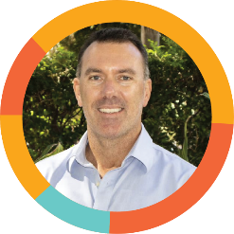
QCOSS Board Chair, Matt Gardiner

The COVID-19 pandemic and Queensland’s flood crises saw the community service sector continue to operate under extreme pressures during the 2021-22 financial year. While Queensland was kept largely safe from COVID-19 outbreaks during 2021, the Queensland Government’s decision to open the state borders at the end of the year saw a large wave of Omicron cases hit the state in December 2021 and January 2022. Just as that wave was peaking, South East Queensland experienced devastating flooding, the impacts of which were exacerbated by the ongoing pandemic.
Despite the personal impacts on staff and services, the community service sector maintained its focus on the needs of Queenslanders facing vulnerability and disadvantage, and supported them throughout these rolling disasters.
At QCOSS, our focus was on supporting the sector advocating for more emergency funding support, more information dissemination, more emergency housing and better disaster payments for affected Queenslanders. We continue to work with the sector to build our readiness and resilience to respond to these disasters as they occur in the future.
Strong outcomes in the 2022 Queensland Budget demonstrate the value of QCOSS’ ongoing member consultation, engagement and advocacy. It was pleasing to see the Queensland Government invest in neighbourhood and community centres, housing and financial support for young people and relief measures for Queenslanders struggling with the costs of living. Work remains to be done in securing sufficient investment in housing, and the relaunch of the Town of Nowhere campaign demonstrates our members’ commitment to achieving this outcome.
I thank my board colleagues, who contribute their expertise, wisdom and experience to guiding QCOSS’ work.
I would also like to acknowledge the ongoing support of the Queensland Government, the Department of Communities, Housing and Digital Economy, and our many other partners and sponsors.
Finally, I thank the QCOSS members, a deeply engaged and committed group of people, who continue to inform and improve our work each year.

CEO’s Report
QCOSS CEO, Aimee McVeigh

Key political milestones saw 2021-22 finish strongly for QCOSS and our members, with the federal election in May 2022 and Queensland Budget in June 2022 driving extensive advocacy for more social housing investment, increases to income support payments and cost of living relief.
These advocacy moments came after 12 months of deep engagement and consultation with our members and the wider sector, as we confirmed policy priorities for government. QCOSS welcomed the election of a new federal government and Prime Minister Anthony Albanese, drawing attention to the potential for him to use his experience growing up in public housing as a motivation for ensuring all children have a roof over their head.
In June, we celebrated the Queensland Government’s funding announcement of ongoing support for neighbourhood and community centres. We also welcomed announcements of increased frontline services for youth housing, the extension of financial support to young Queenslanders leaving out-of-home care until they are 21 years old, and cost of living support for low-income families. We were pleased that in June, the Treasurer, Hon Cameron Dick MP, invited QCOSS to discussions to increase the level of indexation applied to community service funded contracts, in recognition of increased costs of doing business.
It was disappointing that, despite the worsening housing crisis, the Queensland Government made no further commitment to increasing investment in social housing.
Our strength is in raising our voices together. In April, QCOSS together with 11 partners, relaunched our Town of Nowhere campaign. This year, many of our networks have made invaluable contributions to our advocacy. Our CEO Network has worked on the procurement of community services and appropriate indexation of funding. Our Women’s Equality Network informed our submission to the Queensland Government’s Women’s Strategy. Both the Quality Collaboration Network and the Research and Evaluation Network advanced our sector’s collaboration on the role of data, outcomes measurement and governance in building a strong and sustainable sector.
It is always powerful to see the sector come together in person. In June, our 2022 Budget Breakfast welcomed 310 guests for an early morning budget update by the Treasurer, Hon Cameron Dick MP. Throughout the year, our In Conversation series brought the sector together with leading Queensland policy makers, including Attorney-General Hon Shannon Fentiman MP, Under Treasurer Leon Allen, and Dr Chris Sarra, Director-General, Department of Seniors, Disability Services and Aboriginal and Torres Strait Islander Partnerships.
The next 12 months will see more opportunities to raise our voices together as we seek to achieve equality, opportunity and wellbeing for all people, in all communities. Cost of living pressures, in the context of the ongoing housing crisis, will challenge Queenslanders’ resilience. We need more services across Queensland, especially to support young people.
The incredible work of our members is our source of inspiration and hope. Thank you for striving each day to make Queensland a fairer, more equal place.

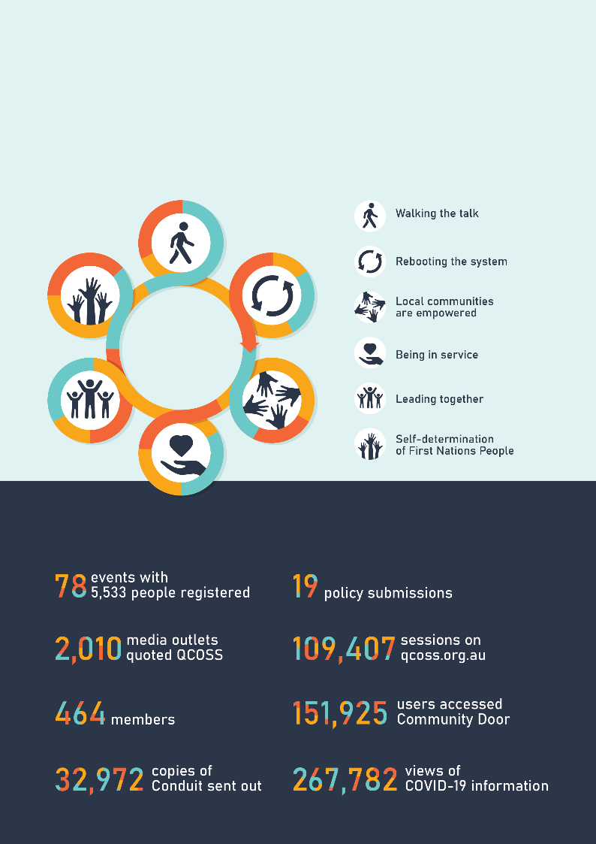
Our Strategic Plan
2021 – 2023
In response to the disruption caused by COVID-19, considering the potential for positive change associated with Queensland’s Human Rights Act and in order to highlight our commitment to self-determination for First Nations People, we have re-set our strategic plan.
The strategic direction and intent of the organisation has not changed. Rather, the plan has been refined and developed, including to ensure our impact is measurable.

Our year in numbers

Rebooting the system
Overturn systems and structures that create and perpetuate inequality

Queensland budget advocacy
Strategic, long-term investments in Queensland’s social infrastructure can end the housing crisis, expand low-income households’ access to the renewable energy revolution, and create good local jobs. QCOSS’ submission for the 2022-23 Queensland Budget reflected these priority areas, and urgent sector concerns reported by members.
In August and September 2021, QCOSS held nine Member Town Halls across Queensland, attended by 178 members. These discussions informed the development of our 2022 Queensland budget submission, which was released for member consultation in November 2021 and finalised, post feedback, in February 2022.

In 2022, our Queensland budget priorities were:
- Secure local community services (addressing indexation)
- Invest in and support local neighbourhood and community centres
- Build more social housing to end child homelessness
- Help low-income households access the energy transformation
- Make the Queensland budget work for everyone (gender responsive budgeting).

On 21 June 2022, the Queensland Government’s budget announcement included:
- Transparency over the community services indexation rate of 2.88%, with a
post-budget commitment to review the indexation process
- $125.6 million over four years to strengthen social services in Queensland, including by increasing the base funding of each government-funded Neighbourhood and Community Centre to $230,000
- $29.8 million over four years for new frontline services for youth housing and homelessness
- Extension of financial support for young Queenslanders
leaving out-of-home care until they are 21 years old
- $16 million immediate response package for families struggling to secure housing
- $6.8 billion in concessions and rebates to lower the cost of living for low-income families, including $385 million to lower electricity bills.

The Queensland Government did not provide any new funding for social housing in the 2022 Queensland Budget.
To support the sector’s budget advocacy, QCOSS hosted Under Treasurer Leon Allen at an In Conversation event on 16 March 2022, attended by 81 members.
The annual QCOSS Budget Breakfast, held on 23 June 2022, was attended by 310 people including QCOSS members, Queensland peak bodies and government department representatives. Treasurer and Minister for Trade and Investment, the Hon Cameron Dick MP presented Queensland’s 2022 Budget and spoke about its impact on the social services sector. The Treasurer publicly committed to working on indexation issues with the sector through QCOSS.
We were pleased to welcome a number of government ministers, including:
- Hon Leeanne Enoch MP, Minister for Communities and Housing, Minister for Digital Economy and Minister for the Arts
- Hon Cameron Dick MP, Treasurer and Minister for Trade and Investment
- Hon Leanne Linard MP, Minister for Children and Youth Justice and Minister for Multicultural Affairs
- Hon Di Farmer MP, Minister for Employment and Small Business and Minister for Training and Skills Development
- Hon Stirling Hinchliffe MP, Minister for Tourism, Innovation and Sport, and Minister Assisting the Premier on Olympics and Paralympics Sport and Engagement
- Hon Craig Crawford MP, Minister for Seniors and Disability Service and Minister for Aboriginal and Torres Strait Islander Partnerships.

2022 federal election
QCOSS supported ACOSS’ federal election advocacy strategy, which included calls to increase the rate of income support payments to at least $70 per day, a strong call for increases to Australian Government investment in social housing and an extension to the National Rent Affordability Scheme, the conclusion of which places more than 8,000 Queensland families at risk of eviction. Our advocacy resulted in media coverage across the state, including in South East Queensland, Cairns, Townsville and Mackay.
In May, QCOSS welcomed the election of a new federal government and Prime Minister Anthony Albanese, drawing attention to the potential for him to use his experience growing up in public housing as a motivation for ensuring all children have a roof over their head.

Advocating for women’s equality
Women are disproportionately affected by structural adversity and crisis impacts, and in a year dominated by COVID-19 and flooding disasters, we intensified our advocacy for gender equality in Queensland.
In October 2021, QCOSS made a submission to the Queensland Government’s consultation towards a new Queensland Women’s Strategy. Our response was developed with input from the QCOSS Women’s Equality Network and focused on improving women’s economic security, health, safety, and embedding a human rights framework.
The Queensland Women’s Strategy 2022-27 was released by the Queensland Government in April 2022. QCOSS was pleased it centred on achieving economic security for women. On 26 April 2022, Hon Shannon Fentiman MP, Attorney-General and Minister for Justice, Women and the Prevention of Domestic and Family Violence, joined CEO Aimee McVeigh for an In Conversation event discussing the strategy in detail.

Produce an evidence-based advocacy program
- Cost of living
Released in December 2021, our Cost of Living report found many Queensland households are struggling to afford the basics, with people increasingly making impossible choices between paying rent, food or bills. Housing was identified as the largest expense for all households surveyed, and most have very little capacity for savings or paying for unplanned expenses.
We do not have to accept poverty, however at current Australian Government income support levels of $45 a day, it is entrenched. QCOSS continued to support ACOSS’ Raise the Rate for Good campaign during 2021-22.
- Barriers to entry: joining the renewable energy future
Many households are currently at a disadvantage in the energy market and miss out on the benefits or bear disproportionate costs depending on whether they can access new or renewable technologies like solar panels.
QCOSS’ Elevating inclusion and equity outcomes within consumer energy product innovation report, published in May 2022, advocated for the market and governments to work together and co-design solutions to the problem of new-energy inclusion moving forward.
- Assessing availability of water hardship provisions
QCOSS’ Water hardship in regional Queensland report, published in March 2022, identified the hardship provisions applicable to regional water providers in Queensland, as well as the hardship support being offered in practice.
The report found there are disparities in the treatment of people across the state, with water customers in South East Queensland who may be experiencing financial hardship being guaranteed access to hardship policies, flexible payment plans and interest waivers that regional Queenslanders are not.
- Bridging the digital divide
QCOSS’ Bridging the Digital Divide report, produced in partnership with The McKell Institute and published in September 2021, found many Australians remain significantly excluded from the digital world through lack of infrastructure access, affordability issues, or lack of ability to use technology.
The report revealed that when vulnerable Queenslanders are unable to afford or confidently use digital technologies, 76 per cent simply go without. On key digital inclusion measures – access to technology, digital affordability, and the ability to use technologies – the report noted Queensland ranks fifth among Australian states, behind the ACT, NSW, WA and Victoria. The leading driver of digital exclusion is data affordability.

Town of Nowhere campaign
Queensland’s housing crisis has worsened with rental vacancies at historic lows, decreasing rental affordability, and a ballooning social housing waitlist. In 2021-22, there were 50,301 Queenslanders on the social housing register, an increase of 3,365 in 12 months.
In March 2022, QCOSS, alongside 11 partners, relaunched our Town of Nowhere campaign, with the aim of ending Queensland’s housing crisis through provision of adequate social and affordable housing.
The relaunch was livestreamed to the QCOSS Facebook audience and generated more than 320 individual media items across print, breakfast and primetime television and online – the latter coverage generated more than 370 comments from readers sharing their housing experiences. Interviews were broadcast on local ABC Radio stations across Queensland featuring campaign partners including Lifeline Darling Downs, St Vincent de Paul Society Queensland, Anglicare Central Queensland, Kyabra Community Association, and 54 reasons.
As part of the campaign, we called on the Queensland Government to increase the Housing Investment Fund by $1 billion in the 2021-22 Queensland Budget, provide an additional $500 million to the QuickStart’s fund to build more social housing in regional Queensland, and deliver solutions for children and young people experiencing homelessness.

QCOSS policy input and advocacy 2021-22
Among other tactics, QCOSS uses submissions and participation in government managed committees
and processes to provide policy input and advocate for better outcomes for Queenslanders.
Submissions that were made this year included:

- Anti-Discrimination Act review
- Child Protection and Other Legislation Amendment Bill 2021
- Housing Legislation Amendment Bill 2021
- Justice Legislation (COVID-19 Emergency Response - Permanency) Amendment Bill 2021
- National Legal Assistance Partnership (NLAP) Strategy and Action Plan Project
- National Women's Safety Plan renewal
- Parliamentary Inquiry into Serious Vilification and Hate Crimes
- Parliamentary inquiry into Social Isolation and loneliness in Queensland
- Procurement Maturity Project and enhancements to the Queensland Procurement Policy
- Proposed amendment to Water Regulation 2016: Increasing the expected duration of water restrictions in South East Queensland
- Purpose, intent and adequacy of the Disability Support Pension Senate inquiry
- Queensland Women’s Strategy
- Raise the age of criminal responsibility (Greens bill)
- Religious Discrimination Bill
- Response to Discussion Paper 1: Options for legislating against coercive control and the creation of a standalone domestic violence offence (the Discussion Paper)
- Response to Discussion Paper 2: Women and girls’ experience of the criminal justice system (the Second Discussion Paper)
- Response to the Women's Safety and Justice Taskforce Discussion (Paper 3)
- Social Services Legislation Amendment (Consistent Waiting Periods for New Migrants) Bill 2021
- Working with Children (Indigenous Communities) Amendment Bill 2021.

We participated in the following government managed committees and processes this year:

- Aboriginal and Torres Strait Islander Legal Assistance Forum (ATSILAF)
- Anti-Discrimination Act 1991 Review Reference Group
- Child Protection Act 1999 reform consultation (Department of Children, Youth Justice and Multicultural Affairs)
- Children and Families Peak Advisory Group (Department of Children, Youth Justice and Multicultural Affairs)
- Community Partnerships Group (Queensland Family and Child Commission)
- Departmental Peaks Service Delivery Communication and Liaison (Department of Children, Youth Justice and Multicultural Affairs)
- Domestic and Family Violence Roundtable (Department of Justice and Attorney General)
- Emergency Housing Security Meeting (Department of Communities, Housing and the Digital Economy)
- Environmental, Social and Corporate Governance Working Group (Department of Resources)
- Housing and Domestic and Family Violence Roundtable (Department of Justice and Attorney General)
- Housing and Homelessness Services Peak and Industry Sector meeting (Department of Communities, Housing and the Digital Economy)
- Human and Social Recovery Committee
- Integrated Framework of Housing with Support for Young People (Department of Communities, Housing and the Digital Economy)
- Joint Procurement Industry Advisory Group (PIAG) and Queensland Government Procurement Committee
- Ministerial Energy Council Sub-Committee Meetings (Department of Energy and Public Works)
- National Coordination Mechanism: Community Support – Flood Relief and Recovery (QLD and NSW) (Australian Government Department of Home Affairs)
- Procurement Industry Advisory Group (PIAG)
- Queensland Industry Recovery Alliance
- Queensland Legal Assistance Forum (QLAF)
- Queensland Women’s Strategy Advisory Group (Department of Justice and Attorney General)
- Queensland Workforce Summit (Department of Employment, Small Business and Training)
- Social Services Category Council Industry Reference Group
- Young People Working Group (Department of Communities, Housing and the Digital Economy)
- Young People’s Housing and Homelessness Policy Working Group (Department of Communities, Housing and the Digital Economy).

Being in service
Support the social services sector

Capacity building
In 2021-22, QCOSS delivered capacity building activities that proactively equipped the sector with the skills and knowledge to do their work, but which also responded in a timely way to emerging issues and challenges within the sector. The capacity building program was informed by member engagement, along with research and policy development.

- Human Services Quality Framework (HSQF): The HSQF assesses and promotes improvement in the quality of human services for the Queensland Government. To help organisations implement quality systems and prepare for their quality assessment activities, QCOSS provides one-on-one and small group support, HSQF specific information and resources including an HSQF eTraining course and policy templates. In 2021-22, QCOSS HSQF policy templates were downloaded more than 11,980 times, with a full review and update of the suite delivered between January - March 2022.
- Quality Collaboration Network (QCN): The QCN meets monthly to support enhancing collaborative practice in the human service sector by identifying and discussing common issues and compliance matters, as well as sharing information, resources and learning. In 2021-22, the QCN launched a new “lunchbox sessions” series examining different quality and compliance challenges and ideas in a casual forum. The network grew to an average of more than 70 registrations per meeting
(an increase of 29 per cent) in 2021-22, resulting in a diverse, engaged, strong membership base.
- Community Door: The Community Door website provides news, resources and information for Queensland’s community sector, including a fortnightly newsletter. More than 450 news items, updates, events and resources were published on the site during 2021-22. The website was viewed 861,011 times, including 78,185 unique visitors to COVID-19 resource pages.
- Energy and water: QCOSS provides policy makers with input into policy decisions and regulations related to essential energy and water services, and helps to educate the sector on issues and policy changes. Advocacy work in 2021-22 focussed on regional water hardship and ensuring fair access, energy subsidy awareness, and for better energy hardship outcomes (with the Australian Energy Regulator).
- Skilling Queenslanders for Work: QCOSS partnered with the Department of Employment, Small Business and Training (DESBT) to deliver tender writing workshops and webinars to support the Skilling Queenslanders for Work (SQW) initiative and build sector capacity more broadly to apply for funding. During 2021-22, QCOSS delivered 25 webinars and in-person sessions across Queensland to 1,159 participants. Workshops were supported through development of new resources, including short videos and templates.
- Data collaboration: The QCOSS report Using consumer data for continuous improvement examined the internal data handling systems of three community service organisations, finding the sector can establish and manage appropriate systems that measure outcomes and improve outcomes for service users. The report recommended standardising data collection approaches, encouraging
cross-organisational collaboration and pooling of resources, and building sector capacity to undertake data analysis.

Supporting human rights in Queensland
Human Rights, Housing and Homelessness
The Human Rights Housing and Homelessness project, delivered in partnership with the Department of Communities, Housing and Digital Economy (DCHDE), was a first-of-its-kind program supporting the development of a human rights culture in Queensland – working to enhance the capability of frontline service providers to deliver services compatibly with the Human Rights Act 2019 (Qld) (“the Act”).
QCOSS engaged with “Human Rights Champions” - five frontline organisations across Queensland working in the housing and homelessness sector, as well as individual staff from DCHDE, to support them to put human rights principles into practice through specialised training and resource provision. More than 1,000 people interacted with the project throughout 2021-22.
Participants were regularly surveyed during the project to measure changes in their capacity to understand and apply the Act in their work. By the end of the project, participants average understanding of the Act had increased from 52 per cent to 75 per cent, a net increase of 23 per cent.
Project highlights:
- four human rights-specific newsletters sent to more than 1,445 subscribers
- one-on-one support provided to 17 people
- four capacity-building events held with 683 people registered
- more than 25 training sessions (face-to-face and online)
- the project culminated in a suite of guides, tools, posters, blogs, videos, webinars, and a case study library - created and made available through a new Human Rights resource hub on Community Door.
Human Rights in Action
Our Human Rights in Action series continued during 2021-22 to improve the capacity of the social service sector to understand how they can use the Act in their work – whether it be in advocacy, service delivery or service design. 452 members registered for one or more of the live webinars examining:
- Serious vilification and hate crimes
- Reforming regulation of restrictive practices
- Queensland Anti-Discrimination Act 1991 in the 21st century.
Sector readiness and response
- COVID-19: QCOSS supported the Queensland Government’s COVID-19 information dissemination through regular news updates, delivering 24 COVID-19 newsletters and news alerts to the sector, and developing three case studies back to government documenting the vaccination campaigns of services.
In November 2021, QCOSS worked with Clayton Utz to develop general legal advice to guide QCOSS member organisations through COVID-19 vaccination mandates and the balance of risks. A webinar was held to support the paper on 30 November 2021, with 591 registered attendees. The paper was downloaded 549 times.
- Floods: The February 2022 flood emergency caused devastation on a massive scale across the Brisbane, Wide Bay-Burnett, and Western Downs regions. QCOSS supported the sector’s response, advocating for crisis response payments and funding for services. In February, QCOSS and ACOSS called for the Federal Government to immediately increase the Disaster Recovery Payment to $3,000 per adult and $1,000 per child. QCOSS also provided timely information on disaster grants, housing supports, legal matters and recovery hubs.

Signature events | In Conversation
QCOSS’ popular In Conversation event series gives the community service sector exclusive access to Queensland’s political leaders and policy makers. In 2021-22, the event series was delivered in partnership with the QUT Centre For Justice, welcoming:
- Under Treasurer Leon Allen | Unpacking the Queensland budget processes (16 March 2022)
- Attorney-General, the Hon. Shannon Fentiman MP | Queensland Women’s Strategy 2022-2027 (26 April 2022)
- Director-General, Department of Seniors, Disability Services and Aboriginal and Torres Strait Islander Partnerships, Dr Chris Sarra | Pathway to Treaty (3 June 2022).
State of the sector
QCOSS’ State of the Sector report found community organisations have experienced increasing pressure due to an increase in overall demand on services during COVID-19, and increases in the complexity of issues presenting. Pressures faced by clients included housing shortages, increased levels of domestic and family violence, and financial wellbeing pressures.
The report was based on the results of the 2021 Australian Community Sector Survey, conducted by the Social Policy Research Centre at UNSW Sydney, and a series of interviews held with leaders and frontline community service workers, supplemented with publicly available data.

Corporate communications
During 2021-22, there was significant increase in engagement with QCOSS’ corporate communications.

- 2,850 media mentions across Australia
- 2,084 Facebook followers
(90 per cent growth)
- 2,454 Linked In followers
(55 per cent growth)
- 2,242 Twitter followers
(6 per cent growth)
- 541 Instagram followers
(218 per cent growth)
- 2,917 Conduit recipients
- 79,496 unique visitors to qcoss.org.au
had 109,407 sessions and 206,580 page views.

Local communities are empowered
Ensure Queenslanders can influence decisions that impact their lives

Projects for positive change
NTSSS (NDIS Training and Skills Support Strategy)
Delivered between 2018 – June 2022, this project built the NDIS workforce through research, support, and training, and was an initiative of the WorkAbility Queensland consortium. In 2021-22, the project launched two innovative and free self-managed eLearning modules on the Community Door eTraining platform:
- NDIS Quality and Safety Compliance Program (September 2021)
- Self-managing your NDIS Plan (November 2021)
QCOSS supported the NTSSS through the Workability Queensland consortium. The NTSSS was finalised on 30 June 2022, having delivered outcomes including:
- direct employment outcomes, including for First Nations people, people from CALD backgrounds and people with lived experience
- supported more than 900 individuals to complete training in an NDIS related qualification, skill set, microcredential or other unaccredited training course
- delivery of a wide range of resources, products and processes that provide a basis for ongoing workforce improvements.
Community Action for a Multicultural Society (CAMS)
Finalised on 30 December 2021, the CAMS program supported increased social connectedness, participation and access for community members from culturally and linguistically diverse (CALD) backgrounds through addressing systemic challenges, raising awareness and developing capacity for inclusion. Throughout the project, QCOSS regularly convened the Queensland Accessing Interpreters Working Group (QAIWG) and provided sector training to ensure greater and more effective use of interpreters’ services throughout Queensland.
The project delivered four capacity building workshops in November 2021:

- Crisis communication that works
- Listen up! We live here, too

- Interpreting matters
- Australia: 300+ languages, English is just one.

Place-based projects
QCOSS proactively manages partnerships with government, community-based organisations, registered training organisations, and other peak bodies to develop collaborative, sustainable local projects.
Targeted Outreach Project
The Targeted Outreach Project (TOP) undertook targeted outreach in communities across Queensland to identify, support and refer potentially eligible applicants to the Queensland Government’s Assessment and Referral Team (ART) to apply for the NDIS.
Concluding in June 2022, the project focused on ensuring that hard-to-reach or marginalised people with disability in Queensland were identified, informed, and intensively supported.
TOP outcomes:
- coordinated 2,472 engagement and capacity building activities
- worked with 8,608 individuals across the social service sector
- engaged with 4,500 organisations
- hosted 14 Local Level Engagement Groups, with 241 organisations participating
- engaged 21 Local Champions with disability across Queensland.
Place-based Community of Practice
With place-based approaches, we have opportunities to ensure the views of people with lived experience are consistently and meaningfully integrated into service design and delivery. QCOSS’s Place-based Community of Practice increased to 915 members during 2021-22, with three meetings held:
- Remote communities: Keeping our communities healthy (July 2021)
- Ensuring the voices of people with lived experiences are heard (October 2021)
- Housing affordability and homelessness: Place-based approaches to promoting housing security and addressing homelessness (November 2021).
Gold Coast Housing and Homelessness Project
QCOSS is an active partner in the Gold Coast Homelessness Network, working to deliver the Service Integration Initiative and to end homelessness on the Gold Coast. As Regional Care Coordinator for the project, QCOSS works closely with the network to enhance engagement between services on the coast – encouraging collaboration and building the sector’s capability to create a more holistic response to homelessness.
Launched at the 2022 Gold Coast Homelessness Symposium in March 2022, the Gold Coast Zero Campaign brings community organisations, government departments, and community members together to end homelessness on the Gold Coast. Using the Advance to Zero methodology, together with other communities of the Australian Alliance to End Homelessness, the campaign delivers coordinated responses, real-time quality information and collaborative advocacy to ensure homelessness on the Gold Coast will be rare, brief, and non-recurring.
Gold Coast Housing Network | COVID-19 Vaccination Response
As Queensland’s COVID-19 vaccination drive ramped up in September 2021, the Gold Coast Homelessness Network (GCHN) coordinated mobile vaccination clinics to protect some of the most vulnerable members of the Gold Coast community.
Between September and December 2021, the GCHN held 35 vaccination clinics for people experiencing or at risk of homelessness on the Gold Coast, at Ashben Medical Centre and community organisation hubs. 215 people attended the clinics.
The collaborative approach to enable access to vaccinations has continued throughout 2022 with regular clinics held at key service delivery hubs.

Queensland Resources Industry Development Plan (QRIDP)
QCOSS partnered with Rowland to develop and deliver a Consultation Program for the development of a QRIDP, feeding back local perspectives to the Queensland Government, and helping communities find pathways out of dips in productivity resulting from the COVID-19 pandemic.
QCOSS and Rowland held eight in-person engagement sessions in Mount Isa, Chinchilla, Rockhampton, Townsville, Mackay, Brisbane, and Moranbah, as well as one online – with 180 people attending in total. A further 10 interviews were undertaken by phone.
The Hon. Scott Stewart MP, Minister for Resources, attended each in-person engagement session (excluding Rockhampton) to welcome participants, and provide background and context on the development of the QRIDP.
Queensland Program of Assistance to Survivors of Torture and Trauma (QPASTT)
In November 2021, QPASTT commissioned QCOSS to design a participatory evaluation for a pilot Youth Voice project in Townsville. The main objectives of the evaluation were to measure progress towards the targeted aims of the pilot and to build the evaluation capacity of young people participating in the program.
QCOSS co-designed the program’s theory-of-change and evaluation methods with a group of 17 young people in Townsville between the ages of 15 and 25, and QPASTT staff. The evaluation measured young people’s satisfaction with the program, as well as impact on young people’s self-development, knowledge, communication and leadership skills.
QCOSS workshopped insights collected through data with program staff to identify key areas of strength and improvements.
Leading together
Harness the power of the social services sector and the community

Networks and influence
QCOSS’ policy networks identify shared challenges and collaboratively generate solutions across the social service sector, identifying emerging issues, advocacy priorities and research objectives. One new network was launched during 2021-22:

- Research and Evaluation Network (new) provides an opportunity for collaboration and knowledge sharing on research and evaluation methods. Over the year, guest speakers present on their own organisational data collection and service evaluation systems, sharing the challenges they experienced and how these were overcome. The network met for the first time on 18 August 2021 and met three times across the year.
- Community Services CEO Network brings together community sector leaders to collaboratively identify issues impacting the wider sector and provide an opportunity to shape solutions, with a focus on structural reform. The network met four times in 2021-22. QCOSS successfully advocated on behalf of the network on:
Insurance: A significant viability issue was identified by a member organisation that supports children after they were unable to secure insurance against physical and sexual abuse. Following advocacy led by our members, Peakcare and QCOSS, the Queensland Government indemnified community organisations while a longer-term solution is developed.
Indexation: In June 2022, the network identified a shortfall in government contracts, with funding failing to meet inflation in year-on-year budgeting. Following QCOSS advocacy, Queensland Treasurer, the Hon. Cameron Dick MP, publicly committed to engage with QCOSS to develop a solution. As part of this work, QCOSS commissioned the University of Western Australia to investigate an appropriate indexation model for social services in Queensland.
- Queensland Peaks Network has a membership of 22 community sector peak bodies with a presence in Queensland. The network enables peaks to collaboratively identify issues impacting the wider sector and provide an opportunity to share perspectives. In September 2021 the network collectively engaged with the Department of Premier and Cabinet to encourage the Queensland Government to apply a human rights framework to future social policy goals for the state.
- Women’s Equality Network responds to and provides advice on matters relating to women’s equality. The network supported the development of QCOSS’ Gender impact analysis of the Queensland Budget 2021-2022 and related 2022 Queensland Budget Submission to formalise gender responsive budgeting in state policymaking. It also supported QCOSS submission to the Queensland Women’s Strategy development. The network met four times in 2021-22.
- Essential Services Consultative Group provides a channel for community organisations to influence energy policy processes and contribute to government policy on key consumer reforms. The network met five times in 2021-22.
- Quality Collaboration Network provides an opportunity to share experiences, information and resources on audit and quality matters, as well as identify common issues across the sector to inform system updates to government. It provides valuable feedback to the Queensland Government on the HSQF review process. The network met 10 times in 2021-22.

Partnering to prosper
Last year, QCOSS supported 27 letters and submissions to government led by other organisations.
National COSS network
In 2021-22, QCOSS worked closely with the national COSS network to progress issues including sector sustainability, affordable and public housing, indexation, the importance of adequate income support payments, and making energy and water affordable.
Australian Community Sector Survey
The ACOSS-led Australian Community Sector Survey is the longest running survey of the community sector by the community sector. QCOSS referred 1,033 people to last year’s survey with more than 700 complete responses recorded.
Raise the Rate for Good
QCOSS continued to advocate for substantial increases to the JobSeeker payment and other income support payments through direct advocacy to government, media and other communications activity.
Data Collaborative Demonstration Project
In 2021-22, QCOSS partnered with Queensland University of Technology (QUT) to begin exploring how community service organisations can better collaborate through shared data. Organisations were recruited in March 2022, with work to commence during the 2022-23 financial year.

A thriving membership
Throughout 2021-22, we have focused on deepening our engagement with members and responding to their needs through our program of work, including across advocacy, research, policy development and capacity building activities. A member survey undertaken in February 2022 showed that, overall, members appreciate QCOSS for its advocacy and for the information we provide; the value of being part of a larger organisation that represents them to the government; and QCOSS’ broad view on social issues, even when their organisation may have a narrower operational focus. The survey showed a clear interest from members to be more engaged in our campaigns, events, research and advocacy.
We work to share relevant and timely information with members, create meaningful capacity building opportunities, engagement networks, and to bring our membership community together. In 2021-22, we sent 32,972 copies of our e-newsletter and brought together more than 5,500 people through our events.
Showcasing our Frontline Heroes
Workers on the frontline of community services across Queensland are the heart of our sector. In 2021-22, we modernised and refreshed our successful Member Profiles into a new and engaging format for social media: #QCOSSFrontlineHeroes. More than 20 profiles were featured during 2021-22.
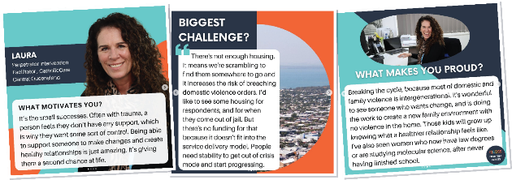

Self-determination of First Nations People
Act on opportunities to improve the ability of First Nations people
to realise their right to self-determination
QCOSS is committed to reconciliation and the self-determination of First Nations Peoples. Throughout
2021-22, QCOSS supported advocacy to enshrine a First Nations Voice to Parliament in the Australian Constitution, and sought to engage and work closely with Aboriginal and Torres Strait Islander People and organisations - including in our capacity building program, research and policy development.
QCOSS observed and celebrated NAIDOC Week and Reconciliation Week.
During Reconciliation Week (27 May – 3 June 2022), Dr Chris Sarra, Director-General, Department of Seniors, Disability Services and Aboriginal and Torres Strait Islander Partnerships, joined QCOSS CEO Aimee McVeigh for an In Conversation to discuss Pathway to Treaty. Speaking on the 30th anniversary of the Mabo decision, Dr Sarra reflected on the Uluru Statement of the Heart, First Nations People’s connection to country, and the Path to Treaty.
Delivered in partnership with QUT Centre for Justice, 77 QCOSS members joined the live event.

Walking the talk
Be a sustainable and strong movement that lives our values
Governance
Throughout 2021-22, the QCOSS Board and management team have continued to strengthen and enhance effective and transparent governance across the organisation.
- Membership fees: A new fee structure was implemented on 1 July 2021, following a strategic review. QCOSS remains committed to operating sustainably.
- QCOSS Constitution: A refreshed Constitution was adopted via a special resolution at the Annual General Meeting in November 2021. Developed by the QCOSS Board and prepared by Hall & Willcox, the Constitution was modernised without modifying the fundamental structure or governance of the organisation.
- Risk appetite statement: Developed with BDO, a Risk Appetite Statement was approved by the QCOSS Board on 17 March 2022.
- Human Resources Strategy 2021-23: Approved by the QCOSS Board in August 2021, this strategy sets out four key priority areas to ensure QCOSS continues striving for a success-driven organisational culture to deliver on our strategic and business plans. The four priority areas are:
- valued, supported, engaged and rewarded employees
- management and leadership excellence
- workforce diversity
- organisational excellence.
In January and February 2022, the Queensland Government endorsed QCOSS for the Preferred Supplier Panels for Market and Social Research, and for Professional Services, placing QCOSS at the forefront of opportunities to lead emerging work in the sector.
Systems
Extensive system improvements were implemented, including:
- Sharepoint upgrade: A new intranet and Sharepoint hierarchy launched in February 2022, streamlining digital document management.
- Adopting IntelliHR: All human resources information was centralised through the use of IntelliHR, including employee information, performance management and travel requests, enhancing workflows by deploying automation.
- Improved budgeting: Calca financial reporting software was implemented, in conjunction with WareConnect invoice automation, which has enabled real time project and organisational budget monitoring and forecasting.
- Microsoft Power BI: the data visualisation tool was integrated into our research work, enabling collaboration, access to data and analysis of relevant key datasets useful for monitoring and evaluation across the community services sector.

Funders and supporters
Thanks to every QCOSS member in every community in Queensland. Without your support we could not even begin to strive for our vision.
Thanks also to our funders and supporters.
Community Services Industry Alliance Ltd (NDIS Training and Skills Support Strategy)
Department of Communities, Housing and Digital Economy (Peaks, COVID-19 Sector Readiness and Response, Human Rights Project, and Housing and Homelessness Action Plan)
Department of Employment, Small Business and Training (Skilling Queenslanders for Work)
Department of Energy and Public Works – Energy Division (Energy)
Department of Regional Development, Manufacturing and Water (Water)
Department of Resources (Queensland Resources Industry Development Plan)
Gold Coast Homelessness Network Inc (Gold Coast Service Integration Initiative)
QPASTT (Queensland Program Assisting Survivors of Torture and Trauma) –
Multicultural Youth Voice Program
Queenslanders with Disability Network Inc (NDIS Targeted Outreach Project)
Rowland Pty Ltd (Queensland Resources Industry Development Project)
Swinburne University of Technology (Finkel Energy Research Project)
The McKell Institute (Bridging the Digital Divide)

Sponsors

54 reasons – State Budget Breakfast
HESTA – State Budget Breakfast
QLeave – CEO Network
QUT Centre for Justice – In Conversation events

Town of Nowhere partners

54 reasons
Anglicare Central Queensland
Catholic Care Central Queensland
Common Ground Queensland
Footprints Community
Kyabra
Lifeline Darling Downs & South West Queensland
Meals on Wheels Queensland
Micah Projects
St Vincent de Paul Society
Wesley Mission Queensland

Pro-bono professional support and advice
BDO Risk Management Advisory Service
Clayton Utz Lawyers
Hall + Wilcox Lawyers

Directors’ Report and financial statements
Directors’ Report
The directors present their report, together with the financial statements, on the company for the year ended 30 June 2022
Directors
The following persons were directors of the company during the whole of the financial year and up to the date of this report, unless otherwise stated:
- Matt Gardiner
- Faiza El-Higzi
- Colleen Tribe
- Kevin Mercer
- Linda McClelland
- Rachelle Patterson
- Lee-Anne Simpson
- Bronwyn Fredericks

Principal activities
QCOSS is the state-wide organisation for individuals and organisations working in the social and community service sector. QCOSS holds a vision for quality, opportunity, and wellbeing for every person in every community. Key activities during the financial year focussed on providing effective policy advice, advocating for policy changes to support the social services sector and the community, working to strengthen responsive community services, and having productive partnerships with communities, the community services sector and government. This work is done with a Queensland free of poverty and disadvantage front of mind.
QCOSS Strategic Priority areas:
Rebooting the system: Overturning systems and structures that create and perpetuate inequality
Local communities are empowered: Ensure Queenslanders can influence decisions that impact their lives
Being in service: Support the social services sector
Leading together: Harness the power of the social services sector and the community
Self-determination of First Nations People: Act on opportunities to improve the ability of First Nations people to realise their right to self-determination
Walking the talk: Be a sustainable and strong movement that lives our values
Operating result
The surplus after providing for income tax amounted to $32,092 (2021 surplus: $19,727). The surplus for 30 June 2022 includes donations received in relation to the social housing Town of Nowhere campaign, which will run over a three-year period, of $230,500 and expenditure of $46,699 relating to the campaign. The company would show a deficit of $151,709 if the social housing Town of Nowhere campaign donations after deduction of related campaign expenditure is excluded.

Performance measures

- A membership that sees value in QCOSS membership

- QCOSS seen by key stakeholders
as the leading authority on issues relating to poverty and disadvantage

- Advice and research to inform policy, program and service design for improved social and economic outcomes is sought and acknowledged

- Advocacy outcomes for access to a basic standard of living and essential services for all Queenslanders

- Collaboration is facilitated between service providers, government, and communities to improve outcomes for people and communities

- Community Sector organisations are prepared for key reforms impacting the sector

- Appropriate organisational resources and structures in place to support delivery of key initiatives

Information on Directors

Matt Gardiner
Qualifications and experience: BSocSc (Couns), M.Clin.Couns., Grad.Dip.
Strategic Leadership, MAICD, FIML
Passionate about social justice, improving systems and therapeutic practice, Matt is an experienced practitioner and has held senior executive roles at some of Australia's leading not-for-profits. He currently serves as a director of several companies and governmental advisory committees. He is proud to contribute to the ongoing strength of QCOSS in its strategic objectives and to represent members across the state.
Currently, Matt’s primary role is CEO of 54 reasons (Save The Children’s Australian services division), leading a large, professional workforce across every state and territory. He has a background in relationship and trauma counselling, disability, child protection, mental health, family law mediation, violence prevention and community development. His experience has included several Social Impact Investments, including leading Australia’s first Social Impact Bond to mature, and he has negotiated several innovative Payment By Outcome (PBO), based on risk/return modelling across a range of sectors. Matt has led mergers and acquisitions in several sectors and segments and enjoys leading through cultural and business transformation.
Matt is Fellow of the Australian Institute of Management, Member of the Australian Institute of Company Directors and has undergraduate qualifications in psychology and counselling, Masters in Clinical Counselling, Grad. Dip. in Strategic Leadership.

- Colleen Tribe
Qualifications and experience: Dip Ed, B.Ed, Grad Dip Special Ed, Grad Cert Specialised Leadership, MAICD
After serving nearly a decade in the General Manager’s role of Roseberry Qld, Colleen is proud of the success she was able to achieve, leading the organisation to the very prominent position it holds within the social sector. Now relocated to Brisbane, Colleen is still focused on ensuring regional issues and interests are highlighted while serving on the QCOSS Board.
Colleen is currently working within the education sector, where she is able to bring her experience and perspective from the NFP and social sector. Her passion is to work with teachers to ensure best possible outcomes and potential are achieved for our children and young people - our children need great teachers in their lives, to inspire and motivate them.
Having an array of experience on boards, Colleen is continuing to enjoy working with such a talented group of people who sit on the QCOSS Board, as well as management and staff of QCOSS.

Faiza El Higzi
Qualifications and experience: BSc (Hons), Grad.Dip Pjt Mgt, MAppSc, MEd. PHD JP(Qual)
Faiza brings over 20 years’ experience in the community sector as a board member, manager, and volunteer, focusing on issues of equity, inclusion and social change.
She is a recipient of the Order of Australia Medal (2020) and Queensland Government Multicultural Award for Outstanding Individual (2018). Faiza is a member of the Queensland Domestic and Family Violence Implementation Council, the Queensland Multicultural Advisory Committee and Metro South Health Consumer Advisory Committee. She is the Chair of the Ethnic Broadcasting Association Queensland, and the national Women of Colour organisation.
Faiza worked in strategic policy at both state and federal government. Her experience in the NGO sector includes community development, refugee settlement and youth engagement. Faiza has several qualifications in Architecture, Project Management, International Business and Education and gender studies. Currently Faiza is an academic with University of Queensland.

Kevin Mercer
Qualifications and experience: B.Com, MBA, GAICD, FCEOI
Kevin Mercer is the Chief Executive Officer of St Vincent de Paul Society Queensland. He joined in February 2019 with more than 30 years of experience in management across a range of sectors, including 10 years in the aged care, community care, disability and retirement living sectors.
Kevin also held management positions in marketing, business development and logistics in a range of industries including retail, manufacturing, consulting, telecommunications, and energy sectors.
Kevin has served as the Chief Executive Aged and Community Care of Mercy Health Australia, and as the Chief Executive Officer of Holy Spirit Care Services.
He holds a Bachelor of Commerce in Accountancy and a Masters of Business Administration (MBA) from the University of Canterbury. He is a Graduate of the Australian Institute of Company Directors and a Fellow of the CEO Institute of Australia. Kevin has also completed Catholic Health Australia’s Ministry Leadership Program.
He has a strong sense of social justice and a life-long passion for learning to improve the lives of those experiencing disadvantage. Kevin has been a Director of QCOSS since April 2019.

Linda McClelland
Qualifications and experience: B.Arts, Grad Cert in Housing Management & Policy, Advanced Diploma of Community Sector Management, Diploma of Management, Diploma of Quality Auditing
Linda is a regional member and has worked with and on boards within the not-for-profit sector for over 30 years. As CEO of Hinchinbrook Community Support Centre, she has grown the centre into the lead community service provider in the Hinchinbrook area.
Linda has grown the centre through her passion for empowering others. This manifests in her commitment to teaching and mentoring, having taught community services through TAFE to both senior high school students and Indigenous workers from throughout North and Far North Queensland.
At a strategic level, she has contributed to the development of the sector training, the recognition of Queensland neighbourhood centres through regional and state neighbourhood centres networks, and the needs of the housing sector through the Townsville Housing & Homelessness Network.

- Rachelle Patterson
Qualifications and experience: B.Psychology, M.Suicidology, Master of Health Promotion
Rachelle is the Chief Operating Officer, Human & Community Services with Lifeline Darling Downs and South West Queensland Limited. She believes that every person has the right to be safe, heard and thriving.
Rachelle has held several executive and frontline positions across out-of-home care, mental health, suicidology, criminology and human services. She has worked in urban, regional and remote settings across Queensland, NSW, ACT and Western Australia.
Rachelle’s work across rural and remote Australia has taught her that best practice and evidence-based models are not always a good fit for their intended populations. Rachelle is passionate about getting service providers and funding bodies to develop and deliver responsive programs and models that respond to the needs of the community and the individual.

- Lee-Anne Simpson
Qualifications and experience: B.Arts, Bachelor of Business (Mmt) (Hons),
Graduate Certificate in Management
Lee-Anne is currently a Regional Manager with Carers Queensland delivering Local Area Coordination Services for the National Disability Insurance Scheme across Central Queensland, Sunshine Coast, and Moreton Bay regions.
Lee-Anne has held several senior management positions across a range of community service organisations and developed partnerships and networks with a diverse range of stakeholders to deliver collaborative projects.
She has worked in both service delivery and policy development across a range of project streams including, child protection, domestic and family violence services, family and relationship services and disability services.
Throughout Lee-Anne’s 20-year history working in the community services sector, she remains committed to championing equitable access to services in regional, remote, and rural communities and advocating for community organisations to receive the funding and support they need to deliver them.

- Bronwyn Fredericks
Qualifications and experience: Dip. T(Sec), B.Educ, M.Educ, M.EducStudies, PhD along with two VET qualifications (Cert IV TAE and a Cert IV in Community Culture)
Bronwyn is a Professor and the Pro Vice-Chancellor (Indigenous Engagement) at the University of Queensland (UQ, Australia). She was previously the Pro Vice-Chancellor (Indigenous Engagement), BHP Billiton Mitsubishi Alliance Chair in Indigenous Engagement and the Chairperson of Academic Board at Central Queensland University (CQUniversity, Australia).
In 2016, Bronwyn was appointed as the Presiding Commissioner with the Queensland Productivity Commission (QPC) to lead the Inquiry into service delivery in Queensland’s remote and discrete Indigenous communities. She additionally worked on the Inquiry into manufacturing, the Inquiry into Imprisonment and Recidivism in Queensland (2019) and the Queensland Recycling Review (2019).
Bronwyn has worked for both state and federal levels of government and has a long history of direct hands-on involvement in Aboriginal and Torres Strait Islander community-based organisations spanning over 30 years. For example, she was Chairperson of the Bidgerdii Community Health Service for some 9 years, a Director of Anglicare Central Queensland, has assisted in the establishment of community organisations, and served on numerous community committees in Central Queensland, Ipswich, and Brisbane.
Bronwyn is a member of the Australian Institute of Aboriginal and Torres Strait Islander Studies (AIATSIS) Research Advisory Committee, the Beyond Blue National Research Advisory Committee, and on numerous other Queensland and national annual awards and policy committees, as well as being a member of the Australian Research Council’s (ARC) College of Experts.
Bronwyn is noted for her community-based research and translating research outcomes along with her strong practice-based commitment to social justice and improving Indigenous health, education, and life outcomes.

Aimee McVeigh (Chief Executive Officer)
Qualifications and experience: B.Laws, B.Communications, Post Grad Dip in Legal Practice, Master International and Public Law, GAICD
Aimee McVeigh is QCOSS’s Chief Executive Officer, and a strong advocate for equality, opportunity and wellbeing for all Queenslanders. As a lawyer and human rights advocate, Aimee led the successful campaign for a Human Rights Act for Queensland and was a founding director of Disability Law Queensland.
Prior to joining QCOSS, Aimee worked in various senior and advisory roles, including at the Disability Royal Commission and the Aboriginal and Torres Strait Islander Women’s Legal and Advocacy Service.
Aimee has been engaged by the United Nations Special Rapporteur on the rights of indigenous peoples as a gender advisor and has worked with a number of non-profit organisations in Queensland, including during the Child Abuse Royal Commission. Aimee was also a state finalist for the 2017 Australian of the Year Awards, and a finalist for the 2019 Australian Human Rights Commission Human Rights Medal.

- Annette Schoone (Company Secretary) GAICD, CPHR
Annette holds the role of Company Secretary. Annette is a graduate of the Australian Institute of Company Directors, holds qualifications in Human Resources, Community Service Management, Community Development and Project Management, coupled with more than 25 years’ experience in management and leadership positions, strategy and operations, governance, and service management gained in local government and the not-for-profit sectors.

Meetings of directors
The number of meetings of the company's Board of Directors ('the Board') and of each Board committee
held during the year ended 30 June 2022, and the number of meetings attended by each director were:
Directors |  | Full Board |  | Finance &  Audit Committee |  | Governance Committee
 |  | Attended | Held | Attended | Held | Attended | Held
Matt | Gardiner | 11 | 11 | 5 | 6 | 3 | 4
Rachelle | Patterson | 10 | 11 | 3 | 3 | 1 | 2
Faiza | El Higzi | 10 | 11 | 5 | 6 | 3 | 4
Colleen | Tribe | 10 | 11 | 2 | 3 | 2 | 2
Linda | McClelland | 11 | 11 | - | - | 4 | 4
Kevin | Mercer | 11 | 11 | 6 | 6 | - | -
Lee-Anne | Simpson | 9 | 11 | - | - | 2 | 4
Bronwyn | Fredericks | 11 | 11 | 1 | 3 | - | -

Held: represents the number of meetings held during the time the director held office or was a member of the relevant committee.

Contributions on winding up
In the event of the company being wound up, ordinary members are required to contribute a maximum of $10 each. The total amount that members of the company are liable to contribute if the company is wound up is $5,000 based on [500] current ordinary members.

Subsequent Events to Reporting Period
There are no subsequent events to be noted.

Auditor's independence declaration
A copy of the auditor's independence declaration as required under Australian Charities and Not for Profits Commission Act 2012 and the Corporations Act 2001 is set out page 7.
This report is made in accordance with a resolution of directors, pursuant to section 298(2)(a) of the Corporations Act 2001.

On behalf of the directors

……………………………………………………………………………………………………..………..
Kevin Mercer
Dated this 5 day of October 2022

DECLARATION OF INDEPENDENCE BY D P WRIGHT TO THE DIRECTORS OF QUEENSLAND COUNCIL OF SOCIAL SERVICE LIMITED

As lead auditor of Queensland Council of Social Service Limited for the year ended 30 June 2022, I declare that, to the best of my knowledge and belief, there have been:
- No contraventions of the auditor independence requirements of the Corporations Act 2011 in relation to the audit; and
- No contraventions of any applicable code of professional conduct in relation to the audit.
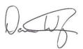
D P Wright
Director

BDO Audit Pty Ltd

Brisbane, 5 October 2022

 | Notes | 2022 | 2021
 |  | $ | $
Revenue | 2 | 3,737,121* | 3,544,862
Employee benefits expense |  | (2,878,018) | (2,704,283)
Depreciation and amortisation Expense | 3 | (153,376) | (151,962)
Loss on Investments | 3 | (152,395) | -
Computer costs |  | (40,701) | (52,157)
Conference/seminar costs |  | (31,347) | (46,225)
Consultancy fees |  | (122,915) | (217,312)
Travel and accommodation |  | (35,457) | (23,611)
Printing and stationery |  | (26,908) | (22,902)
Rent | 3 | (1,853) | (1,800)
Postage |  | (605) | (1,137)
Telephone |  | (15,314) | (18,209)
Other expenses |  | (246,140) | (285,537)
Surplus/(Deficit) before income tax expense |  | 32,092 | 19,727
Income tax expense | 1 | - | -
Surplus/(Deficit) after income tax expense for the year |  | 32,092 | 19,727
Other comprehensive income for the year, net of tax |  |  | -
Total comprehensive income for the year |  | 32,092 | 19,727
* Revenue includes restricted donations, refer note 2 for details.

The accompanying notes form part of these financial statements

 | Notes | 2022 | 2021
 |  | $ | $
CURRENT ASSETS
Cash and cash equivalents | 4 | 1,638,533 | 1,217,935
Trade receivables | 5 | 189,063 | 110,118
Other current assets | 6 | 43,906 | 44,583
TOTAL CURRENT ASSETS |  | 1,871,502 | 1,372,636
NONCURRENT ASSETS
Property, plant and equipment | 8 | 16,706 | 23,560
Right of use Assets | 11 | 467,205 | 570,655
Investments | 7 | 1,503,752 | 1,729,146
TOTAL NONCURRENT ASSETS |  | 1,987,663 | 2,323,361
TOTAL ASSETS |  | 3,859,165 | 3,695,997
CURRENT LIABILITIES
Trade and other payables | 9 | 1,354,512 | 1,139,176
Lease Liabilities | 11 | 141,016 | 147,428
TOTAL CURRENT LIABILITIES |  | 1,495,528 | 1,286,604
NONCURRENT LIABILITIES
Long-term provisions | 10 | 17,491 | 10,745
Lease Liabilities | 11 | 353,377 | 437,970
TOTAL NONCURRENT LIABILITIES |  | 370,868 | 448,715
TOTAL LIABILITIES |  | 1,866,396 | 1,735,319
NET ASSETS |  | 1,992,769 | 1,960,678
EQUITY
Social Housing reserve |  | 183,801 | -
Retained surpluses |  | 1,808,968 | 1,960,678
TOTAL EQUITY |  | 1,992,769 | 1,960,678
The accompanying notes form part of these financial statements

 |  | Retained surpluses | Social housing reserve | Total
 |  | $ |  | $
Balance as at 1 July 2020 |  | 1,940,951 | - | 1,940,951
Surplus after income tax expense for the year |  | 19,727 | - | 19,727
Other Comprehensive Income, net of tax |  | - | - | -
Total Comprehensive Income |  | 1,960,678 | - | 1,960,678
Balance as at 30 June 2021 |  | 1,960,678 | - | 1,960,678
Balance as at 1 July 2021 |  | 1,960,678 | - | 1,960,678
Surplus/(Deficit) after income tax expense for the year |  | 32,092 | - | 32,092
Other Comprehensive Income, net of tax |  | - | - | -
Total Comprehensive Income |  | 32,092 | - | 32,092
Transfers from retained earnings to reserve – Note 18 |  | (183,801) | 183,801 | -
Balance as at 30 June 2022 |  | 1,808,968 | 183,801 | 1,992,769
The accompanying notes form part of these financial statements

 | Notes | 2022 | 2021
 |  | $ | $
CASH FLOW FROM OPERATING ACTIVITIES
Receipts from government grants, members, and clients |  | 3,908,839 | 3,768,605
Payments to suppliers and employees |  | (3,428,902) | (3,354,410)
Interest received |  | 1,736 | 14,212
Net cash provided by/ (used in) operating activities | 14(b) | 481,673 | 428,407
CASH FLOW FROM INVESTING ACTIVITIES
Payment for property, plant, and equipment |  | (43,071) | 11,539
Payment for investments |  | - | (1,701,481)
Proceeds from investments |  | 72,999 | -
Net cash provided by/ (used in) investing activities |  | 29,928 | (1,689,942)
CASH FLOW FROM FINANCING ACTIVITIES
Repayment of Leases |  | (91,003) | (166,170)
Net cash provided by/ (used in) financing activities |  | (91,003) | (166,170)
Net increase/(decrease) in cash and cash equivalents |  | 420,597 | (1,427,705)
Cash at beginning of financial year |  | 1,217,935 | 2,645,642
Cash at end of financial year | 14(a) | 1,638,533 | 1,217,937

The accompanying notes form part of these financial statements

Note 1: statement of significant accounting policies

General information
The financial statements cover Queensland Council of Social Service Ltd a not-for-profit unlisted public company limited by guarantee, incorporated, and domiciled in Australia. The financial statements are presented in Australian dollars, which is the company’s functional and presentation currency.
Its registered office and principal place of business are:
Ground Floor
20 Pidgeon Close
West End Qld 4101

A description of the nature of the company’s operations and its principal activities are included in the directors’ report, which is not part of the financial statements.
The financial statements were authorised for issue, in accordance with a resolution of directors, on 22 September 2022. The directors have the power to amend and reissue the financial statements.

Basis of preparation
These general-purpose financial statements have been prepared in accordance with Australian Accounting Standards – Simplified Disclosures issued by the Australian Accounting Standards Board (‘AASB’), the Australian Charities and Not for Profits Commission Act 2012(ACNC 2012), as appropriate for not-for-profit oriented entities. These financial statements also comply with International Financial Reporting Standards as issued by the International Accounting Standards Board (‘IASB’).

Historical cost convention
The financial statements have been prepared under the historical cost convention.
- Revenue From Contracts with Customers
Sales revenue
Customer co-contributions, member’s contributions and other fundraising are recognised when received or receivable.
Donations
Donations are recognised at the time the revenue is received.
Grants from Government Departments
Specific purpose funding arrangements from government departments require funds to be used for specific objectives, outcomes, outputs and performance benchmarks or milestones related to the delivery of specific projects and improvements in service delivery or reform. Where these arrangements are determined to be enforceable through legal or equivalent means and contain sufficiently specific obligations relating to the delivery of goods and services, revenue would be recognised in accordance with AASB 15. If such funding does not meet the ‘sufficiently specific’ and ‘enforceability’ criteria of AASB 15, income is recognised under AASB 1058 when the recipient entity controls the cash.
General assistance funding
General revenue assistance arrangements (JobKeeper, cash boost and Covid-19 emergency relief) allow funds to be used for the broad objectives of the entity. Such funding is unlikely to meet the ‘sufficiently specific’ criteria in AASB 15. Accordingly, these arrangements will generally be recognised as income under AASB 1058 when the entity obtains control of the cash.

Note 1: statement of significant accounting policies (cont’d)
Deferred Income
Deferred income represents grants received in advance for next financial year or unexpended grants recognised under AASB 15, which under the terms of agreement with the grantors, are refundable or have performance conditions which are not yet satisfied.
Interest
Interest revenue is recognised as interest accrues using the effective interest method.
Other revenue
Other revenue is recognised when it is received or when the right to receive payment is established.
- Income Tax
As the company is a charitable institution in terms of subsection 50-5 of the Income Tax Assessment Act 1997, as amended, it is exempt from paying income tax.
- Current and non-current classification
Assets and liabilities are presented in the statement of financial position based on current and non-current classification.
An asset is current when: it is expected to be realised or intended to be sold or consumed in normal operating cycle; it is held primarily for the purpose of trading; it is expected to be realised within twelve months after the reporting period; or the asset is cash or cash equivalent unless restricted from being exchanged or used to settle a liability for at least twelve months after the reporting period. All other assets are classified as non-current.
A liability is current when: it is expected to be settled in normal operating cycle; it is held primarily for the purpose of trading; it is due to be settled within twelve months after the reporting period; or there is no unconditional right to defer the settlement of the liability for at least twelve months after the reporting period. All other liabilities are classified as non-current.
- Cash and Cash Equivalents
Cash and cash equivalents includes cash on hand, deposits held at call with financial institutions, other short-term, highly liquid investments with original maturities of six months or less that are readily convertible to known amounts of cash and which are subject to an insignificant risk of changes in value.
- Trade and other receivables
Trade receivables are initially recognised at fair value and subsequently measured at amortised cost using the effective interest method, less any allowance for expected credit losses. Trade receivables are generally due for settlement within 30 days.
Impairment
The company applies the simplified approach permitted by AASB 9, which requires expected lifetime losses to be recognised from initial recognition of the receivables. Management has determined that assessment of expected credit loss associated with trade receivables is immaterial.

- Plant, plant, and equipment
Plant and equipment is stated at historical cost less accumulated depreciation and impairment. Historical cost includes expenditure that is directly attributable to the acquisition of the items.
Depreciation is calculated on a straight-line basis to write off the net cost of each item of property, plant and equipment over their expected useful lives as follows:
Class of fixed asset Useful lives Depreciation basis
Motor Vehicles 4 years Straight Line
Office Equipment 4 to 5 years Straight Line
Furniture, Fixtures and Fittings 10 years Straight Line
Library 10 years Straight Line

Note 1: statement of significant accounting policies (cont’d)
The residual values, useful lives and depreciation methods are reviewed, and adjusted if appropriate, at each reporting date.
An item of property, plant and equipment is de-recognised upon disposal or when there is no future economic benefit to the Company. Gains and losses between the carrying amount and the disposal proceeds are taken to profit or loss.

- Impairment of non-financial assets
Non-financial assets are reviewed for impairment whenever events or changes in circumstances indicate that the carrying amount may not be recoverable. An impairment loss is recognised for the amount by which the asset’s carrying amount exceeds its recoverable amount.
- Trade and other payables
These amounts represent liabilities for goods and services provided to the company prior to the end of the financial year and which are unpaid. Due to their short-term nature, they are measured at amortised cost and are not discounted. The amounts are unsecured and are usually paid within 30 days of recognition.
- Employee Benefits
Short-term employee benefits
Liabilities for wages and salaries, including non-monetary benefits, annual leave and long service leave expected to be settled within 12 months of the reporting date are recognised in current liabilities in respect of employees’ services up to the reporting date and are measured at the amounts expected to be paid when the liabilities are settled.
Other long-term employee benefits
The liability for annual leave and long service leave not expected to be settled within 12 months of the reporting date are recognised in non-current liabilities, provided there is an unconditional right to defer settlement of the liability. The liability is measured as the present value of expected future payments to be made in respect of services provided by employees up to the reporting date using the projected unit credit method. Consideration is given to expected future wage and salary levels, experience of employee departures and periods of service. Expected future payments are discounted using market yields at the reporting date on national government bonds with terms to maturity and currency that match, as closely as possible, the estimated future cash outflows.
- Fair value measurement
When an asset or liability, financial or non-financial, is measured at fair value for recognition or disclosure purposes, the fair value is based on the price that would be received to sell an asset or paid to transfer a liability in an orderly transaction between market participants at the measurement date; and assumes that the transaction will take place either: in the principle market; or in the absence of a principle market, in the most advantageous market.
Fair value is measured using the assumptions that market participants would use when pricing the asset or liability, assuming they act in their economic best interest. For non-financial assets, the fair value measurement is based on its highest and best use. Valuation techniques that are appropriate in the circumstances and for which sufficient data are available to measure fair value, are used, maximising the use of relevant observable inputs, and minimising the use of unobservable inputs.
- Goods and Services Tax (GST) and other similar taxes
Revenues, expenses, and assets are recognised net of the amount of associated GST, unless the GST incurred is not recoverable from the tax authority. In this case it is recognised as part of the cost of the acquisition of the asset or as part of the expense.
Receivables and payables are stated inclusive of the amount of GST receivable or payable. The net amount of GST recoverable from, or payable to, the tax authority is included in other receivables or other payables in the statement of financial position.

Note 1: statement of significant accounting policies (cont’d)
Cash flows are presented on a gross basis. The GST components of cash flows arising from investing or financing activities which are recoverable from, or payable to the tax authority, are presented as operating cash flows.
Commitments and contingencies are disclosed net of the amount of GST recoverable from, or payable to, the tax authority.
- Leases
The Company leases office, equipment, and vehicle. Rental contracts are typically made for fixed periods of 1 to 5 years but may have extension options. Lease terms are negotiated on an individual basis and contain a wide range of different terms and conditions. The lease agreements do not impose any covenants other than the security interests in the leased assets that are held by the lessor.
Until the 2020 financial year, leases of property, plant and equipment were classified as either finance leases or operating leases. From 1 July 2019, leases are recognised as a right-of-use asset and a corresponding liability at the date at which the leased asset is available for use by the Company.
Assets and liabilities arising from a lease are initially measured on a present value basis.

Lease Liabilities

Lease liabilities include the net present value of the following lease payments:

- Fixed payments (including in-substance fixed payments), less any lease incentives receivable;
- Variable lease payment that are based on an index or a rate, initially measured using the index or rate as at the commencement date;
- The exercise price of a purchase option if the Company is reasonably certain to exercise that option; and
- Payments of penalties for terminating the lease, if the lease term reflects the Company exercising that option.
- Any initial direct costs, and
- Restoration costs.

- Right-of-use assets are generally depreciated over the shorter of the asset’s useful life and the lease term on a straight-line basis. If the Company is reasonably certain to exercise a purchase option, the right-of-use asset is depreciated over the underlying asset’s useful life.

- Critical Accounting Estimates and Judgments
The preparation of the financial statements requires the use of certain critical accounting estimates. It also requires management to exercise its judgement in the process of applying the company’s accounting policies. The areas involving a higher degree of judgement or complexity, or areas where assumptions and estimates are significant to the financial statements.
Estimation of useful lives of assets
The company determines the estimated useful lives and related depreciation and amortisation charges for its property, plant and equipment and finite life intangible assets. The useful lives could change significantly as a result of technical innovations or some other event. The depreciation and amortisation charge will increase where the useful lives are less than previously estimated lives, or technically obsolete or non-strategic assets that have been abandoned or sold will be written off or written down.

Note 2: revenue
 |  | 2022  $ | 2021  $
Operating activities
QCOSS project funding |  | 3,052,507 | 2,795,814
Membership Income |  | 311,200 | 192,520
Other income |  | 141,178 | 289,151
Social Housing Campaign Funding - Restricted |  | 230,500* | -
 |  | 3,735,385 | 3,277,485
Non-operating activities
Interest |  | 1,736 | 14,212
COVID-19 Recovery |  | - | 225,500
Gain on Investments |  | - | 27,665
 |  | 3,737,121 | 3,544,862

*Relates to donations received in relation to the social housing Town of Nowhere campaign which will run over a period of three years. Expenditure relating to social housing Town of Nowhere campaign was $46,699 as at 30 June 2022.

Note 3: expenses
 |  | 2022  $ | 2021  $
Surplus before income tax includes the following specific expenses:
Depreciation and amortisation of non-current assets |  | 153,376 | 151,962
Loss on Investments |  | 152,395 | -
Rental expense on operating leases
- Minimum lease payments (low value lease) – property |  | 1,853 | 1,800

Note 4: cash and cash equivalents
 |  | 2022  $ | 2021  $
Cash on hand |  | 8 | 169
Cash at bank* |  | 1,589,152 | 625,393
Deposits at call |  | 49,373 | 592,373
 |  | 1,638,533 | 1,217,935
* Cash at bank includes restricted cash of $183,801 relating to the social housing Town of Nowhere campaign which will run over a period of three years.
Note 5: trade receivables
 |  | 2022  $ | 2021  $
Trade receivables |  | 189,063 | 110,118

Note 6: other current asset
 |  | 2022  $ | 2021  $
Accrued Interest |  | - | 586
Prepayments and other receivable |  | 43,906 | 463
Accrued Income |  | - | 43,534
 |  | 43,906 | 44,583

Note 7: investments
Non-Current |  | 2022  $ | 2021  $
Financial Assets at Fair Value through Profit and Loss |  | 1,503,752 | 1,729,146

Note 8: plant and equipment
 |  | 2022  $ | 2021  $
PROPERTY, PLANT AND EQUIPMENT
(a) Office equipment
At cost |  | 111,958 | 137,172
Less accumulated depreciation |  | (95,252) | (113,612)
 |  | 16,706 | 23,560
(b) Office furniture and fittings
At cost |  | 14,229 | 14,229
Less accumulated depreciation |  | (14,229) | (14,229)
 |  | - | -
Total property, plant, and equipment |  | 16,706 | 23,560
Reconciliation
Movement in the carrying amounts for each class of property, plant and equipment between the
beginning and the end of the current financial year.
 |  | Furniture  and Fittings | Office  Equipment | Total
2022 |  | $ | $ | $
Balance at the beginning of the year |  | - | 23,560 | 23,560
Additions - cost |  | - | 7,038 | 7,038
Depreciation expense |  | - | (13,892) | (13,892)
Carrying amount at end of year |  | - | 16,706 | 16,706

2021 |  | $ | $ | $
Balance at the beginning of the year |  | 51 | 29,279 | 29,330
Additions |  | - | 7,351 | 7,351
Depreciation expense |  | (51) | (13,070) | (13,121)
Carrying amount at end of year |  | - | 23,560 | 23,560

Note 9: trade and other payables
 |  | 2022  $ | 2021  $
Trade payables |  | 13,230 | 72,600
GST Payable |  | 103,921 | 43,307
Annual leave |  | 238,923 | 188,244
Accrued expenses |  | 147,253 | 156,986
Long service and other leave |  | 59,015 | 75,810
Deferred grant income |  | 466,846 | 408,454
Memberships received in advanced |  | 234,283 | 138,349
Other income received in advance |  | 91,041 | 55,426
 |  | 1,354,512 | 1,139,176

Note 10: provisions
 |  | 2022  $ | 2021  $
NONCURRENT
Employee entitlements – Long service leave |  | 17,491 | 10,745

Note 11: right-of-use assets and leased liability

Right-of-use Assets |  | 2022  $ | 2021  $
Leased building – right-of-use |  | 669,790 | 669,790
Accumulated amortisation – Leased Buildings |  | (234,725) | (100,469)
Total Leased Building |  | 435,065 | 569,321
Motor Vehicle |  | 45,574 | 12,007
Accumulated amortisation – Motor Vehicle |  | (13,434) | (10,673)
Total Motor Vehicle |  | 32,140 | 1,334
Total Right-Of-use Assets |  | 467,205 | 570,655

Lease liabilities |  | 2022  $ | 2021  $
CURRENT
Leases for building premise |  | 130,892 | 145,958
Leases for vehicle |  | 10,124 | 1,440
 |  | 141,016 | 147,398
Lease liabilities |  | 2022  $ | 2021  $
NON-CURRENT
Leases for building premise |  | 330,493 | 437,970
Leases for vehicle |  | 22,884 | -
 |  | 353,377 | 437,970
Reconciliation
Movement in the carrying amounts for each class of right of use assets between the beginning and the end of the current financial year.
 |  | Premises | Motor Vehicle | Total
2022 |  | $ | $ | $
Balance at the beginning of the year |  | 569,321 | 1,334 | 570,655
Additions |  | - | 39,501 | 39,501
Amortisation expense |  | (134,256) | (8,695) | (142,951)
Carrying amount at end of year |  | 435,065 | 32,140 | 467,205

Note 12: contingent liability
The company has a bank guarantee of $49,373 that relates to the lease agreement at 20 Pidgeon Close, which is secured by a term deposit. There are no other contingent liabilities.

Note 13: related party transactions
There were no related party transactions during 2022 financial year or in the prior year.
Key management personnel – disclosures relating to key management personnel are set out in note 16.

Note 14: cash flow information
 |  | 2022  $ | 2021  $
- Reconciliation of cash
Cash at the end of the financial year as shown in the cash flow statement is reconciled to the related items in the balance sheet as follows:
Cash on hand |  | 8 | 169
Cash at bank |  | 1,589,152 | 625,393
At call deposits with financial institutions |  | 49,373 | 592,373
 |  | 1,638,533 | 1,217,935
- Reconciliation of cash flow from operations with Profit after income tax
Surplus before income tax expense |  | 32,092 | 19,727
Noncash flows in profit:
Depreciation |  | 153,376 | 151,962
Fair value decrease in investments |  | 152,395 | -
Changes in assets and liabilities:
Decrease/(increase) in receivables |  | (78,945) | 79,188
Decrease/(increase) in other current assets |  | 588 | (38,944)
Increase/(decrease) in payables |  | (59,370) | 39,286
Increase/(decrease) in accruals and provisions |  | 29,138 | (9,245)
Increase/ (decrease) in deferred income |  | 252,399 | 186,432
Cash flows from operations |  | 481,673 | 428,407

Note 15: financial instruments
- Risk Management
The Company is exposed to the following risks from their use of financial instruments:
- Market Risk
- Credit Risk
- Liquidity Risk
The Directors of the Company have overall responsibility for risk management. The Directors have established risk management policies designed to identify and monitor risks from financial instruments and ensure any adverse effects from these risks are minimized. The Directors meet on a regular basis to review compliance with risk management policy and to analyse financial risk exposure in the context of the current economic environment.
- Interest Rate Risk
Interest rate risk is the risk that a financial instrument's value will fluctuate because of changes in market interest rates. Interest rate risk arises on balances of cash and cash equivalents. The entity minimises this risk by using a term deposit facility. The Company is exposed to interest rate risk and the effective weighted average interest rates on classes of financial assets and financial liabilities, is as follows:
 | Weighted Average |  |  |  | Fixed Interest Rate Maturing
 | Effective  Interest Rate |  | Floating  Interest Rate |  | Within  1 Year |  | 1 to 5  Years
 | 2022 | 2021 | 2022 | 2021 | 2022 | 2021 | 2022 | 2021
Financial Assets: | % | % | $ | $ | $ | $ | $ | $
Cash | 0.20 | 0.35 | 1,588,872 | 625,393 | 49,373 | 592,373 | - | -
Total Financial Assets |  |  | 1,588,872 | 625,393 | 49,373 | 592,373 | - | -

- Credit Risk
Credit is the risk that one party to a financial instrument will cause a financial loss for the other party by failing to discharge an obligation.
Credit risk arises on trade and other receivables. The objective of the entity is to minimise exposure to credit risk. The maximum exposure to credit risk, excluding the value of any collateral or other security, at balance date to recognised financial assets is the carrying amount of those assets, net of any provisions for doubtful debts, as disclosed in the statement of financial position and notes the financial statements.
The Company does not have any material credit risk exposure to any single debtor or group of debtors under financial instruments entered into by the Company.
- Liquidity Risk
Liquidity risk is the risk that an entity will encounter difficulty in meeting obligations associated with financial liabilities. The Company is largely dependent on government funding for grants to continue its operations during the year. It has always been the Company’s priority to maintain a good relationship with all government departments and ensure all contractual obligations have been met each year.
Remaining contractual maturities
The following tables detail the Company’s remaining contractual maturity for its financial instrument liabilities. The tables have been drawn up based on the undiscounted cash flows of financial liabilities based on the earliest date on which the financial liabilities are required to be paid.

Note 15: financial instruments (cont’d)
Trade and Other Payables are expected to be paid and deferred income utilised as follows:
 |  |  |  | 30 June 2022 | 30 June 2021
 |  |  |  | $ | $
Less than 6 months |  |  |  | 848,738 | 779,659
6 months to 1 year (50% of annual leave, deferred income not expensed and lease liabilities) |  |  |  | 646,793 | 506,765
Total |  |  |  | 1,495,531 | 1,286,424

- Net Fair Values
The net fair values of listed investments have been valued at the quoted market bid price at balance date adjusted for transaction costs expected to be incurred. For other assets and other liabilities, the net fair value approximates their carrying value. Financial assets where the carrying amount exceeds net fair values have not been written down as the Company intends to hold these assets to maturity.
The aggregate net fair values and carrying amounts of financial assets and financial liabilities are disclosed in the statement of financial position and in the notes to the financial statements
- Sensitivity Analysis
The Company has performed a sensitivity analysis relating to its exposure to interest rate risk at balance date. This sensitivity analysis demonstrates the effect on the current year results and accumulated funds which could result from a change in this risk.
Interest Rate Sensitivity Analysis:
At 30 June 2022, the effect on profit and equity because of changes in the interest rate, with all other variables remaining constant, would be as follows:
 | Year Ended  30 June 2022 | Year Ended  30 June 2021
 | $ | $
Change in profit attributable to members
-Increase in interest rate by 1% | 15,891 | 7,676
-Decrease in interest rate by 1% | (15,891) | (7,676)

Note 16. Key management personnel discloures
Compensation
The aggregate compensation made to the members of key management personnel of the Company is set out below:
 |  |  |  |  |  | 2022 |  | 2021
Short-term employee benefits |  |  |  |  |  | 697,513 |  | 672,808
Long-term benefits |  |  |  |  |  | 11,383 |  | 15,401
Post-employment benefits |  |  |  |  |  | 76,522 |  | 70,765
 |  |  |  |  |  | 785,418 |  | 758,974
Related party transactions
Related party transactions are set out in note 12.
Note 17. Remuneration of auditors
During the financial year the following fees were paid or payable for services provided by BDO Audit Pty Ltd:
Audit of the financial statements |  |  |  | 36,750 |  | 36,500

Note 18. Social housing reserve
Reconciliation of social housing reserve
Opening balance | - | -
Receipt of donations during the year | 230,500 | -
Expenditure during the year | (46,699) | -
 | 183,801 | -

During the year QCOSS has partnered with its member-based organisations to become founding partners and raise funds to be part of the social housing Town of Nowhere 2.0 campaign to build sustained public support and a political environment for governments to make major investments into social housing and to enact legislative reforms over a period of three years. The reserve relates to the funds received which will be spent over the next three years and as the funds are spent, the expenditure would be transferred to profit or loss statement over the years.

Note 19: capital risk management
The entity’s objectives when managing capital are to safeguard their ability to continue as a going concern, so that they can continue to provide benefits for stakeholders and maintain an optimal capital structure to reduce the cost of capital.
To maintain or adjust the capital structure, the entity may sell assets to reduce its debts.
Consistent with others in the industry, the entity monitors capital based on the net gearing ratio. Net debt is calculated as total borrowings less cash and cash equivalents.
Note 20: economic dependence
The Company is dependent on receiving government grants for most of its revenue used to operate the business. At the date of this report the directors have no reason to believe the Company will not continue to receive grants from the government.
Note 21: events subsequent to balance date
There are no material events after 30 June 2022 requiring disclosure.

In the directors' opinion:
- the attached financial statements comprising the statement of profit or loss and other comprehensive income, statement of financial position, statement of changes in equity and statement of cashflows and accompany notes, are in accordance with the Australian Charities and Not for Profits Commission Act 2012;
- comply with International Financial Reporting Standards as issued by the International Accounting
Standards Board as described in note 1 to the financial statements and Australian Charities and Not for Profits Commission Regulation 2013(ACNC Regulation 2013);
- the attached financial statements and notes thereto give a true and fair view of the company's financial position as at 30 June 2022 and of its performance for the financial year ended on that date; and
- there are reasonable grounds to believe that the company will be able to pay its debts as and when they become due and payable.
Signed in accordance with a resolution of directors made pursuant to subsection 60.15(2) of the ACNC Regulation 2013.
On behalf of the directors

Chair
Brisbane

Brisbane, 5 October 2022

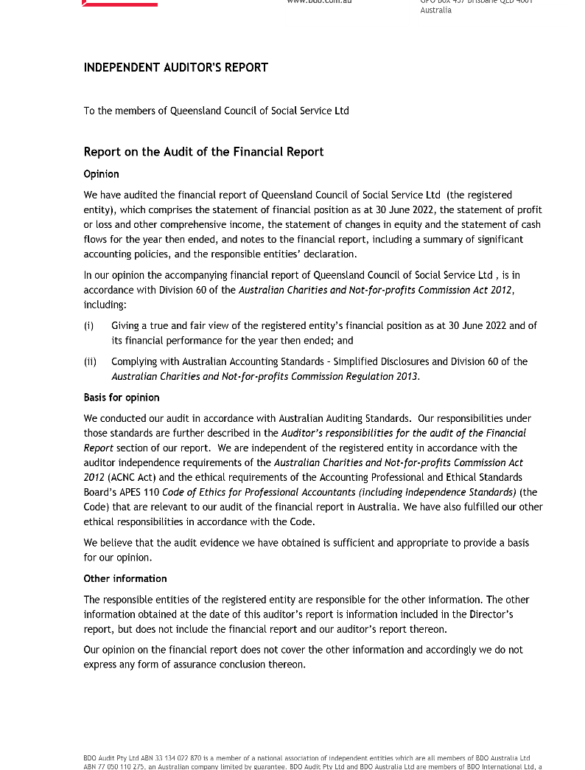

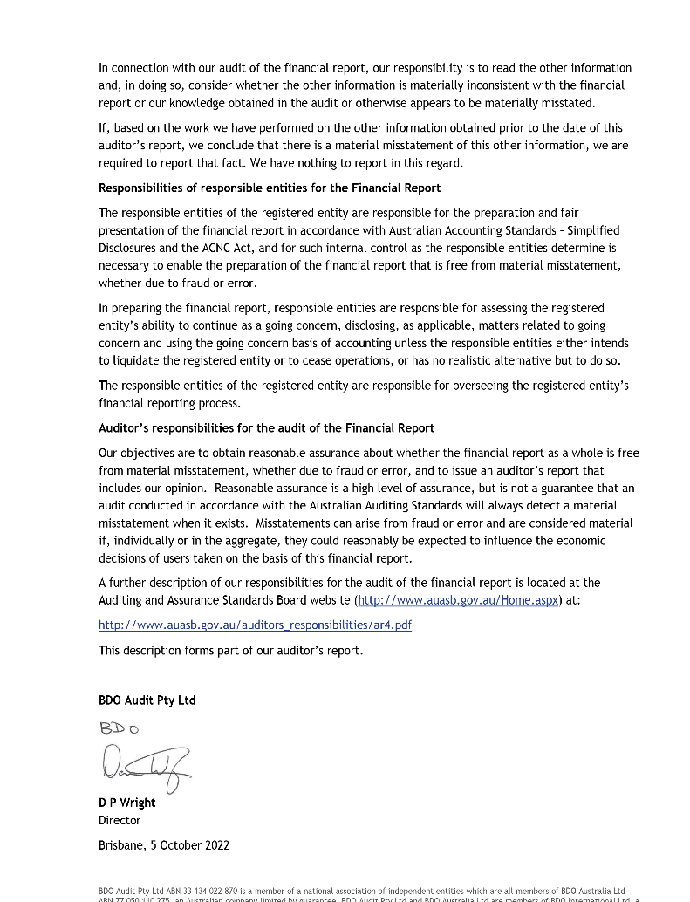

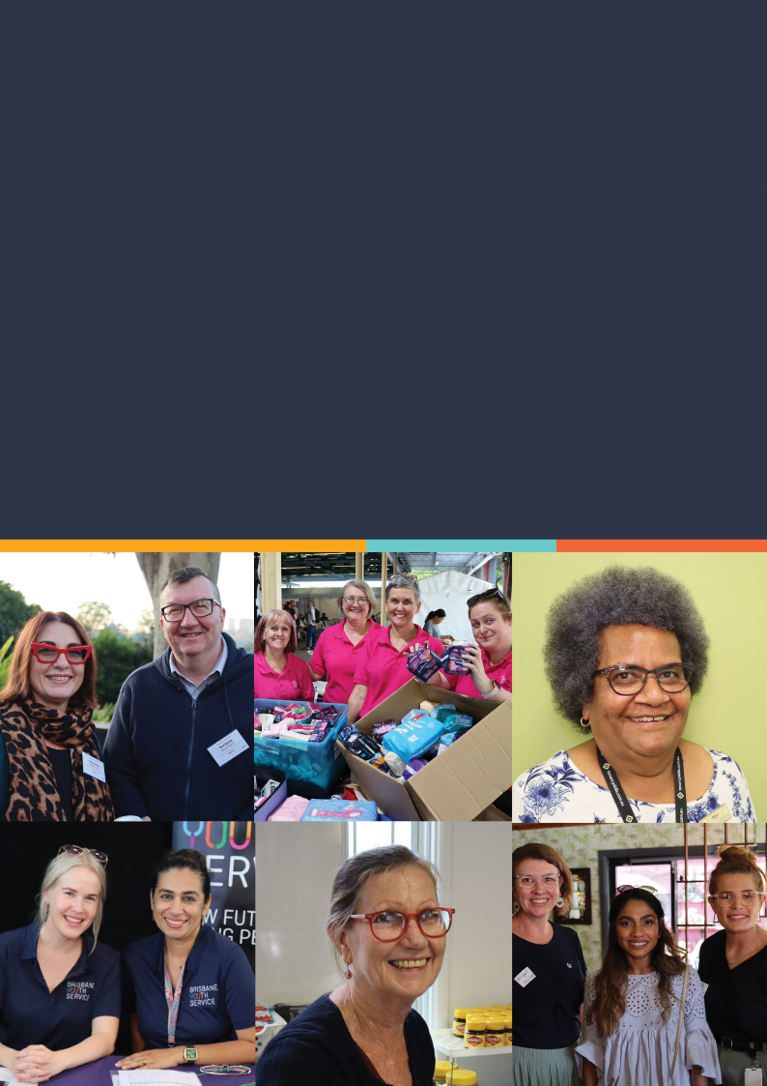

Queensland Council of Social Service Ltd
07 3004 6900 | qcoss@qcoss.org.au | www.qcoss.org.au

